CSS ISLAMIC STUDIES · T7KB
بِسۡمِ ٱللَّهِ ٱلرَّحۡمَٰنِ ٱلرَّحِيمِ
Topic VII — Extremism, Terrorism, Sectarianism and Jihad
The Knowledge Base · Extremism and the middle path, its rise in the Muslim world and Pakistan, its motives and cure, sectarianism and polarisation, Jihad and Fasad, and Paigham-e-Pakistan
Nine chapters built from the syllabus line 'Rise of extremism' and from the eight questions set on this topic between 2015 and 2026, with the contemporary debates, the examiner's record, five likely questions, a numbered one-liner bank and section-by-section revision notes. Every point carries its evidence — the Quran first, then the Hadith, then the Companions, the jurists, the data and the law — inside the point itself.
Edition of September 2026 · covers the papers of 2015–2026 · written for CSS 2027 and after
Contents
HOW TO BUILD THE CONTENTS
The Contents below is left empty on purpose. In Microsoft Word, right-click anywhere on the grey line below and choose Update Field → Update entire table → OK. The full table of contents with page numbers will appear.
On a Mac: right-click (or Control-click) the line → Update Field. If you edit the notes later, repeat this step to refresh the page numbers. You can also press Ctrl + A then F9 (Windows) to update every field in the document at once.

How to Use This Document 9
What this topic covers 9
How this document is built 10
Part Zero — The ABC Before the Chapters 11
0.1 The words of this topic 11
0.2 The scale of the problem 11
Chapter 1 · Extremism: Meaning and the Islamic Position (Wasatiyyah) 13
1.1 The meaning of extremism 13
(1) The words 13
(2) The definition 13
1.2 The Islamic position — the middle path (Wasatiyyah) 13
(1) The Quran 14
(2) The Sunnah 15
(3) The Prophet ﷺ corrected extremism in worship 15
1.3 The Khawarij — the first extremists and the Prophetic warning 15
(1) The prophecy 15
(2) The history 16
(3) The features of Khawarij thinking — then and now 16
1.4 The kinds of extremism 16
1.5 The signs of an extremist mindset 17
1.6 Is extremism a challenge to Islam? (2019) 17
(1) Yes — and more a betrayal than a challenge 17
(2) How it challenges Islam 17
1.7 Wasatiyyah in practice — the balances of Islam 18
1.8 The classical creed against takfir 18
1.9 From words to weapons — how extremism grows 18
Chapter 2 · The Rise of Extremism in the Muslim World 20
2.1 Extremism in Muslim history — before the modern age 20
2.2 The modern rise — the causes and turning points 20
2.3 The common roots across the Muslim world 20
2.4 The main extremist groups — know the names 21
2.5 The evidence that extremism is not Islam 21
2.6 Case note — ISIS (Daesh) 21
2.7 Case note — Afghanistan and its effects on Pakistan 21
2.8 Why young people join — push and pull factors 22
2.9 Extremism is not a Muslim monopoly 22
Chapter 3 · Extremism and Terrorism in Pakistan: The Motives and Causes 23
3.1 Extremism and terrorism — the difference 23
3.2 The phases of terrorism in Pakistan 23
(1) The Afghan war legacy (1979–2001) 23
(2) After 9/11 (2001–2007) 23
(3) Open war on the state (2007–2014) 24
(4) The turning point (2014–2018) 24
(5) The resurgence (2021 onwards) 24
3.3 The reasons and motives — the roots 24
(1) Religious and ideological 24
(2) Political 25
(3) Socio-economic 25
(4) External 25
(5) Psychological, social and digital 25
(6) Legal and administrative 25
3.3a The cost of terrorism for Pakistan 26
3.4 The motives of terrorists (2018) 26
3.5 Three case studies 26
(1) Swat (2007–2009) 26
(2) Karachi (1990s–2013) 26
(3) Balochistan 26
Chapter 4 · Eliminating Extremism: The Teachings of the Holy Prophet ﷺ and a National Plan 28
4.1 The teachings of the Holy Prophet ﷺ against religious extremism 28
(1) Ease, not hardship 28
(2) Gentleness in correction 28
(3) The sanctity of life 28
(4) No suicide 29
(5) No takfir 29
(6) No armed groups against the Ummah 30
(7) Correcting wrong the right way 30
(8) Dialogue with those who disagree 30
4.2 The teachings of the Holy Prophet ﷺ against political extremism 30
(1) Tolerance of opposition 30
(2) Consultation and respect for differing views 31
(3) Truthful speech — no propaganda 31
(4) No harm to public life 32
(5) Justice to opponents 32
(6) A constitution for all 32
4.3 A national plan — the state's response 32
(1) The National Action Plan (NAP), 24 December 2014 32
(2) Military operations 33
(3) Institutions and laws 33
(4) Madrasa reform 33
(5) De-radicalisation 33
(6) The counter-narrative 33
4.4 Society's role — how society can get rid of extremism (2018, 2023) 33
4.4a Education — the long-term cure 34
4.4b The role of mothers and women 34
4.5 Lessons from other Muslim countries 34
4.6 Justice and development as counter-terrorism 34
4.7 The Prophetic way with rebels and dissenters 35
4.8 The door of repentance — the Islamic basis of rehabilitation 35
Chapter 5 · Sectarianism and Polarisation: Causes and Solutions 37
5.1 The meanings 37
5.2 The Quran on division 37
5.3 The Sunnah on division 39
5.4 How difference was handled by the Companions and the Imams — the adab of disagreement 39
5.5 The causes of sectarianism and polarisation in the Muslim world 39
(1) Historical and political 39
(2) Geopolitical rivalry 40
(3) Religious 40
(4) Social and economic 40
(5) Media and digital 40
(6) Political polarisation 40
5.5a The cost of sectarian conflict in the Muslim world 40
5.6 Sectarianism in Pakistan 41
5.7 The solutions in the light of Islamic teachings 41
(1) Unity on the fundamentals 41
(2) The adab of disagreement 41
(3) No takfir 41
(4) Reconciliation 42
(5) Education 42
(6) Law and governance 42
(7) Media and social media 42
(8) Against political polarisation 42
(9) Muslim world level 42
5.8 What all Muslims share 42
5.9 Political polarisation in Pakistan 42
5.10 Case note — Kurram and the way of the jirga 43
Chapter 6 · Jihad: Concept, Kinds, Principles and Conditions 44
6.1 The meaning of Jihad 44
(1) Literal meaning 44
(2) Technical meaning 44
6.2 The kinds of Jihad 44
(1) Jihad against the self (jihad al-nafs) 45
(2) Jihad by knowledge and the word 45
(3) Jihad by wealth 45
(4) Jihad by fighting (qital) 46
(5) Other forms in the Sunnah 46
6.3 The stages of the command to fight 46
6.4 The principles and conditions of Jihad (qital) 46
(1) A lawful authority — the state 46
(2) A just cause 47
(3) The right intention 47
(4) Invitation and warning before fighting 47
(5) Honouring treaties 47
(6) Protecting non-combatants 48
(7) Proportionality — no transgression 48
(8) Humane treatment of prisoners 48
(9) Peace whenever offered 49
(10) Individual conditions 49
6.4a Jihad in the Constitution and law of Pakistan 49
6.5 The Islamic laws of war and the Geneva Conventions 49
6.6 Martyrdom (shahadah) — and why suicide is not martyrdom 50
6.7 The Makkan lesson — restraint under persecution 50
Chapter 7 · Jihad and Fasad: Jihad in the Present International Scenario 52
7.1 The meaning of Fasad 52
Terrorism as hirabah 53
7.2 The difference between Jihad and Fasad 53
7.3 The practical application of Jihad in the current international scenario 54
(1) Defensive jihad by the state 54
(2) Struggles for freedom and against occupation 54
(3) Jihad of the pen and the word 54
(4) Jihad against ignorance, poverty and disease 54
(5) Jihad against corruption and injustice 54
(6) Jihad against the self 55
(7) Economic and technological jihad 55
(8) Information jihad 55
7.4 What is not jihad today 55
7.5 Verses misused by extremists — read in context 55
Chapter 8 · Paigham-e-Pakistan and the National Response 57
8.1 What Paigham-e-Pakistan is 57
8.2 Its main points 57
8.3 Why it matters 58
8.4 A critical evaluation 58
8.5 The wider national response — an overview 58
8.6 Online radicalisation — the new front 59
8.7 The role of youth and education 59
8.8 The role of the ulema and the media 59
8.9 Counter-narratives across the Muslim world 59
8.10 How to measure success 60
Chapter 9 · Extremism and the Contemporary Challenges of the Muslim Ummah 61
9.1 Extremism among the Ummah's challenges 61
9.2 Why extremism is a challenge to Islam itself 61
9.3 The Ummah's collective response 61
Part Two — Contemporary Challenges, Narratives and Hot Debates 63
9.1 The resurgence of terrorism after 2021 63
9.2 Mob violence in the name of religion 63
9.3 Takfir and hate on social media 64
9.4 Madrasa reform — the debate 64
9.5 Extremism and the youth bulge 64
9.6 Talks or operations? The record of peace deals 64
9.7 Security, CPEC and the economy 64
Part Three — The Examiner's Record and Five Likely Questions 65
10.1 Every question on this topic, 2015–2026 65
10.2 What the record teaches 65
10.3 Five likely questions 65
Part Four — The One-Liner Bank 66
One-liners · Extremism and Wasatiyyah 66
One-liners · The rise of extremism 66
One-liners · Extremism in Pakistan 66
One-liners · Eliminating extremism 67
One-liners · Sectarianism 67
One-liners · Jihad 68
One-liners · Jihad and Fasad; Paigham-e-Pakistan 68
Part Five — Revision Notes · Topic 7 70
R7.0 The whole topic in one picture 70
R7.1 Chapter 1 · Extremism and Wasatiyyah (2019) 70
1.1 Meaning 70
1.2 The Islamic position (draw the middle path) 70
1.3 The Khawarij 70
1.4–1.5 Kinds and signs 70
1.6 Is extremism a challenge to Islam? 71
R7.2 Chapter 2 · Rise of extremism in the Muslim world 71
R7.3 Chapter 3 · Reasons and motives in Pakistan (2017, 2018, 2023) 71
3.1 Extremism vs terrorism 71
3.2 Phases (draw the timeline) 71
3.3 Roots (draw the tree) 72
3.3a–3.5 Cost and case studies 72
3.4 Motives of terrorists (2018) 72
R7.4 Chapter 4 · Eliminating extremism (2024; second limb of 2017, 2018, 2023) 72
4.1 Prophet's ﷺ teachings — religious extremism 72
4.2 Prophet's ﷺ teachings — political extremism 72
4.3 The state's plan 72
4.4 Society's role (2018, 2023) 73
R7.5 Chapter 5 · Sectarianism and polarisation (2026) 73
R7.6 Chapter 6 · Jihad (2020) 73
R7.7 Chapter 7 · Jihad and Fasad (2015) 74
R7.8 Chapter 8 · Paigham-e-Pakistan and the national response 74
R7.8a Chapter 9 · Extremism and the Ummah's challenges (2019) 75
R7.9 Part Two · Today 75
R7.10 The figures to draw in the paper 75

How to Use This Document

What this topic covers
Topic 7 carries the syllabus line 'Rise of extremism' — but the examiner has made it the most repeated family of the whole paper: extremism or terrorism in Pakistan in 2017, 2018, 2019, 2023 and 2024, sectarianism in 2026, and Jihad in 2015 and 2020. Every one of these questions wants causes and solutions, proved from the Quran and Sunnah, and applied to Pakistan.
Syllabus line / past question | Where it is taught
Extremism and the Islamic middle path; 'Is extremism a challenge to Islam?' (2019) | Chapter 1
The rise of extremism in the Muslim world | Chapter 2
Reasons and motives of extremism and terrorism in Pakistan (2017, 2018, 2023) | Chapter 3
Eliminating extremism through the Prophet's ﷺ teachings (2024); society's role (2018, 2023) | Chapter 4
Sectarianism and polarisation in the Muslim world (2026) | Chapter 5
Jihad: principles and conditions (2020) | Chapter 6
Jihad and Fasad; Jihad in today's international scenario (2015) | Chapter 7
Paigham-e-Pakistan and the national response | Chapter 8
Extremism among the Ummah's contemporary challenges (2019) | Chapter 9

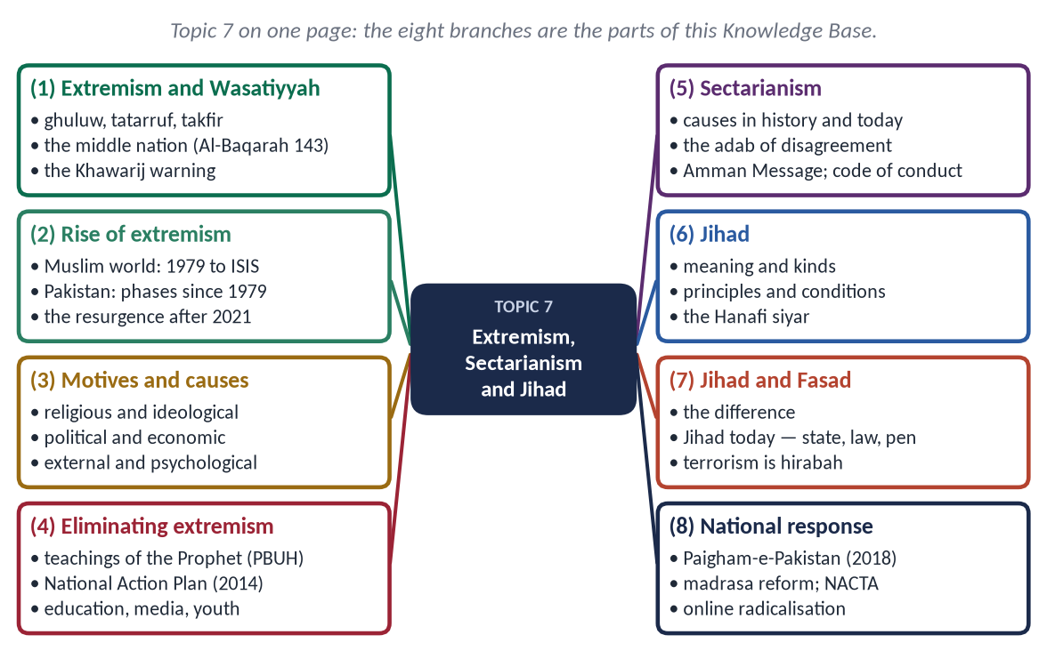
Figure 1 · Topic 7 on one page. The eight branches are the parts of this Knowledge Base.

How this document is built
1. Part Zero — the ABC: the words of the topic and the scale of the problem.
2. Part One — nine chapters; in every point the evidence comes Quran → Hadith → Companions and jurists → scholars, data and law.
3. At-a-glance charts after long sections — the names only.
4. Part Two — contemporary challenges and hot debates.
5. Part Three — the examiner's record and five likely questions.
6. Part Four — the numbered one-liner bank.
7. Part Five — section-by-section revision notes.
EXAMINER'S EYE · THIS TOPIC IN THE PAPER
Five questions on extremism in Pakistan look alike but differ in one key word: 'reasons' (2017), 'motives of terrorism' (2018), 'a challenge to Islam' (2019), 'how can society get rid' (2023), 'religious and political extremism … teachings of the Holy Prophet ﷺ' (2024). Build each answer around its own key word. The answer must be firm against terrorism, fair in its causes, and practical in its solutions.

TRAP · NO SECT, NO NAMES, NO FATWAS
Never name a sect as 'the extremists'. Speak of ideas and acts — takfir, suicide attacks, rebellion, hate speech — which every school condemns. Quote Paigham-e-Pakistan, signed by scholars of all schools, as the common Pakistani position.

Part Zero — The ABC Before the Chapters

0.1 The words of this topic
Term | Arabic | Meaning in this topic
Ghuluw | غُلُوّ | Going beyond the limits in religion — the Prophet's ﷺ own word for extremism.
Tatarruf | تَطَرُّف | Extremism; literally 'standing at the edge' (taraf).
Tashaddud | تَشَدُّد | Harshness, rigidity.
Tanattu' | تَنَطُّع | Hair-splitting severity — 'the extremists perished' (Muslim).
Wasatiyyah | وَسَطِيَّة | The middle, balanced path (Al-Baqarah 143).
Irhab | إِرْهَاب | Terrorism in modern Arabic (distinct from the Quranic 'deterrence' of Al-Anfal 60).
Takfir | تَكْفِير | Declaring a Muslim a disbeliever — the gateway to extremist violence.
Khawarij | خَوَارِج | 'Those who went out' — the first extremist sect, who rebelled against Ali (RA).
Fitnah | فِتْنَة | Discord, trial, sedition.
Fasad | فَسَاد | Corruption and mischief in the land.
Hirabah | حِرَابَة | Waging war on society — armed robbery, terror (Al-Ma'idah 33).
Baghy | بَغْي | Armed rebellion against a lawful state.
Jihad | جِهَاد | Striving in the way of Allah — in many forms.
Qital | قِتَال | Armed fighting — one form of Jihad.
Ta'assub | تَعَصُّب | Bigotry, blind partisanship.
Firqah-wariyyat | فرقہ واریت | Sectarianism (Urdu).

0.2 The scale of the problem
Fact | Figure
Pakistanis killed in terrorism, 2001–2018 | Over 80,000, civilians and security personnel
Economic losses, 2001–2018 | Over 126 billion dollars (Pakistan Economic Survey)
Army Public School, Peshawar | 16 December 2014 — about 147 killed, most of them children
Global Terrorism Index 2025 | Pakistan ranked second most affected country
After August 2021 | A sharp resurgence of attacks, mainly in Khyber Pakhtunkhwa and Balochistan

Chapter 1 · Extremism: Meaning and the Islamic Position (Wasatiyyah)
The foundation of every answer — and the direct subject of 2019: 'Is extremism a challenge to Islam?'

1.1 The meaning of extremism

(1) The words
- Tatarruf (تَطَرُّف) — from taraf, the edge: standing at the far end, away from the centre.
- Ghuluw (غُلُوّ) — exceeding the limit; the Prophet's ﷺ own word.

(2) The definition
Extremism is going beyond the limits set by Allah in belief, word or action — in making religion harder than Allah made it, in condemning others, and in using force where Allah did not permit it. In a wider sense it is any rigid, intolerant position — religious, political, ethnic or secular — that denies the rights of others and accepts violence against them.

1.2 The Islamic position — the middle path (Wasatiyyah)
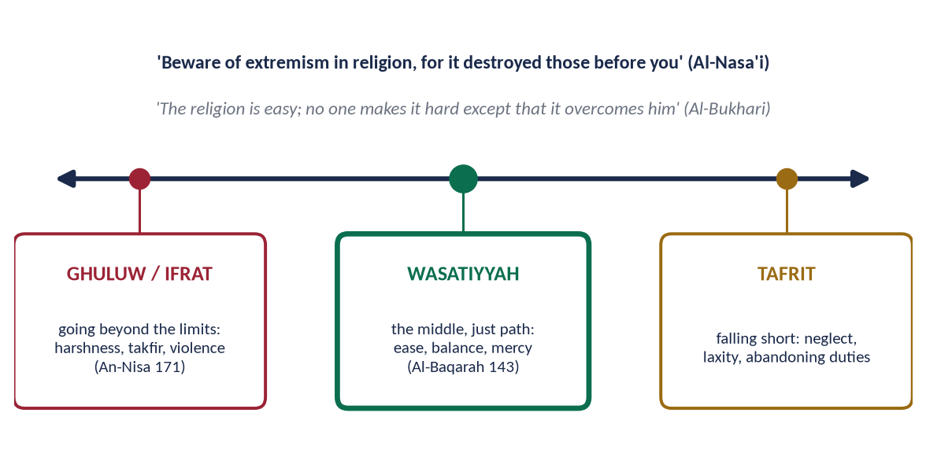
Figure 2 · Ghuluw, Wasatiyyah and Tafrit: the Islamic middle path.

(1) The Quran
✦ QURAN
﴿وَكَذَٰلِكَ جَعَلۡنَٰكُمۡ أُمَّةٗ وَسَطٗا لِّتَكُونُواْ شُهَدَآءَ عَلَى ٱلنَّاسِ وَيَكُونَ ٱلرَّسُولُ عَلَيۡكُمۡ شَهِيدٗاۗ …﴾
“And thus We have made you a middle (just) nation, that you may be witnesses over mankind and the Messenger a witness over you.” (Al-Baqarah, Quran)
➜ 'We have made you a middle nation (ummatan wasatan), that you may be witnesses over mankind.'

✦ QURAN
﴿… لَا تَغۡلُواْ فِي دِينِكُمۡ وَلَا تَقُولُواْ عَلَى ٱللَّهِ إِلَّا ٱلۡحَقَّۚ …﴾
“O People of the Scripture, do not go to extremes in your religion, and do not say about Allah except the truth.” (An-Nisa, Quran)
➜ 'Do not go to extremes in your religion, and do not say about Allah except the truth.'

✦ QURAN
﴿قُلۡ يَـٰٓأَهۡلَ ٱلۡكِتَٰبِ لَا تَغۡلُواْ فِي دِينِكُمۡ غَيۡرَ ٱلۡحَقِّ …﴾
“Say: O People of the Scripture, do not exceed the limits in your religion beyond the truth.” (Al-Ma'idah, Quran)
➜ Say: O People of the Scripture, do not exceed the limits in your religion beyond the truth.

✦ QURAN
﴿… يُرِيدُ ٱللَّهُ بِكُمُ ٱلۡيُسۡرَ وَلَا يُرِيدُ بِكُمُ ٱلۡعُسۡرَ …﴾
“Allah intends for you ease and does not intend for you hardship.” (Al-Baqarah, Quran)
➜ Allah intends ease for you, and does not intend hardship.

✦ QURAN
﴿… هُوَ سَمَّىٰكُمُ ٱلۡمُسۡلِمِينَ مِن قَبۡلُ وَفِي هَٰذَا …﴾
“It is He who named you 'Muslims' before and in this [Quran].” (Al-Hajj, Quran)
➜ He has not placed upon you any hardship in religion.

(2) The Sunnah
✦ HADITH
إِيَّاكُمْ وَالْغُلُوَّ فِي الدِّينِ، فَإِنَّمَا أَهْلَكَ مَنْ كَانَ قَبْلَكُمُ الْغُلُوُّ فِي الدِّينِ
“Beware of extremism in religion, for those before you were destroyed only by extremism in religion.” (Al-Nasa'i and Ibn Majah)
➜ The Prophet ﷺ named ghuluw as the destroyer of nations.

✦ HADITH
هَلَكَ الْمُتَنَطِّعُونَ
“The extremists perished.” (Muslim)
➜ He said it three times.

✦ HADITH
إِنَّ الدِّينَ يُسْرٌ، وَلَنْ يُشَادَّ الدِّينَ أَحَدٌ إِلَّا غَلَبَهُ
“The religion is easy, and no one makes it hard except that it overcomes him.” (Al-Bukhari)

✦ HADITH
يَسِّرُوا وَلَا تُعَسِّرُوا، وَبَشِّرُوا وَلَا تُنَفِّرُوا
“Make things easy, not hard; give good news, do not drive people away.” (Al-Bukhari and Muslim)

(3) The Prophet ﷺ corrected extremism in worship
- The three men — one vowed to pray all night, one to fast every day, one never to marry. The Prophet ﷺ said: 'I pray and I sleep, I fast and I break my fast, and I marry women; whoever turns away from my Sunnah is not of me' (Al-Bukhari and Muslim).
- Mu'adh (RA) lengthened the congregational prayer until a worker left it; the Prophet ﷺ asked him three times, 'Are you a trouble-maker (fattan), O Mu'adh?' (Al-Bukhari).
- 'Abdullah ibn 'Amr (RA) wished to fast every day and pray every night; he was told: 'your body has a right over you, your eyes have a right over you, your wife has a right over you' (Al-Bukhari).

1.3 The Khawarij — the first extremists and the Prophetic warning

(1) The prophecy
When Dhul-Khuwaysirah told the Prophet ﷺ, 'Be just!', he replied, 'Woe to you — who will be just if I am not?' He did not punish the man, but warned of people who would come from his kind:
✦ HADITH
يَقْرَءُونَ الْقُرْآنَ لَا يُجَاوِزُ حَنَاجِرَهُمْ، يَمْرُقُونَ مِنَ الدِّينِ كَمَا يَمْرُقُ السَّهْمُ مِنَ الرَّمِيَّةِ
“They will recite the Quran but it will not go beyond their throats; they will pass out of the religion as an arrow passes through its target.” (Al-Bukhari and Muslim)
➜ Piety of form without understanding.

✦ HADITH
يَقْتُلُونَ أَهْلَ الْإِسْلَامِ وَيَدَعُونَ أَهْلَ الْأَوْثَانِ
“They will kill the people of Islam and leave the idol-worshippers alone.” (Al-Bukhari and Muslim)
➜ The mark of the Khawarij — then and now.

(2) The history
After the arbitration at Siffin (37 AH / 657), a group left Ali (RA)'s army with the slogan 'judgement belongs only to Allah' (la hukma illa lillah). Ali (RA) said:
✦ FROM THE SIRAH
كَلِمَةُ حَقٍّ أُرِيدَ بِهَا بَاطِلٌ
“A word of truth by which falsehood is intended.” (Muslim)
➜ A true slogan used for a false purpose — the method of every extremist movement.

- Dialogue first: Ali (RA) sent Ibn Abbas (RA) to debate them; thousands returned after hearing him.
- Force only against violence: when the rest began killing Muslims (including the Companion 'Abdullah ibn Khabbab and his wife), Ali (RA) fought them at Nahrawan (38 AH / 658).
- Justice even to them: Ali (RA) refused to call them disbelievers — 'they fled from disbelief' — and ordered that the wounded not be finished off nor the fleeing pursued.

(3) The features of Khawarij thinking — then and now
Feature | Evidence
Takfir of sinners and rulers | They declared Ali (RA) and Mu'awiyah (RA) disbelievers
Literalism without understanding | 'The Quran does not go beyond their throats'
Violence against Muslims | 'They kill the people of Islam'
Contempt for scholars | They rejected the Companions' understanding
Self-righteousness | Only their group are true believers
Rebellion against the state | Armed revolt in the name of 'Allah's rule'

1.4 The kinds of extremism
- Religious extremism — harshness in religion, takfir, violence in its name.
- Sectarian extremism — hatred and violence against other schools (Chapter 5).
- Political extremism — intolerance of opponents, hate speech, violence and street chaos; refusal to accept election results or the rule of law.
- Ethnic and separatist extremism — violence in the name of language or region.
- Secular or liberal extremism — contempt for religion and religious people; the denial of their rights.
- Economic extremism — greed that exploits and excludes (Topic 5).

1.5 The signs of an extremist mindset
- (a) One's own opinion as the only truth; no respect for difference.
- (b) Making obligatory what Allah made optional, and forbidden what He allowed.
- (c) Harshness in speech and manner — against the Prophet's ﷺ gentleness (Aal-e-Imran 159).
- (d) Suspicion and ill-thinking of Muslims (Al-Hujurat 12).
- (e) Takfir — declaring others disbelievers.
- (f) Justifying violence against those who disagree.

1.6 Is extremism a challenge to Islam? (2019)

(1) Yes — and more a betrayal than a challenge
Extremism does not come from Islam; it comes against it. It contradicts the Quran's middle path, the Prophet's ease and mercy, and the Shari'ah's first aim — the protection of life.

(2) How it challenges Islam
- It distorts Islam's image — feeding Islamophobia (Topic 6).
- It kills Muslims most of all — most victims of terrorism are Muslims.
- It divides the Ummah — takfir and sectarian war.
- It destroys Muslim states — Iraq, Syria, Afghanistan, Somalia, the Sahel.
- It blocks progress — fear, lost investment, closed schools (the Taliban's closure of girls' schools in Swat, 2008–09).
- It gives enemies an excuse — foreign intervention, 'war on terror' pressures.
✦ QURAN
﴿… مَن قَتَلَ نَفۡسَۢا بِغَيۡرِ نَفۡسٍ أَوۡ فَسَادٖ فِي ٱلۡأَرۡضِ فَكَأَنَّمَا قَتَلَ ٱلنَّاسَ جَمِيعٗا وَمَنۡ أَحۡيَاهَا فَكَأَنَّمَآ أَحۡيَا ٱلنَّاسَ جَمِيعٗاۚ …﴾
“Whoever kills a soul — unless for a soul or for corruption in the land — it is as if he had slain mankind entirely; and whoever saves one, it is as if he had saved mankind entirely.” (Al-Ma'idah, Quran)
➜ Whoever kills a soul, unless for a soul or for corruption in the land, it is as if he had slain mankind entirely.

✦ HADITH
الْمُسْلِمُ مَنْ سَلِمَ الْمُسْلِمُونَ مِنْ لِسَانِهِ وَيَدِهِ
“The Muslim is the one from whose tongue and hand the Muslims are safe.” (Al-Bukhari and Muslim)
➜ By the Prophet's ﷺ own definition, the extremist fails the test of being a Muslim.

1.7 Wasatiyyah in practice — the balances of Islam
Balance | How Islam keeps the middle
World and Hereafter | 'Seek the Hereafter, but do not forget your share of this world' (Al-Qasas 77)
Body and soul | Fasting and eating, prayer and sleep — the Prophet's ﷺ own routine
Individual and society | Personal rights with duties to family and community
Justice and mercy | Law is applied, but forgiveness is preferred (Ash-Shura 40)
Firmness and gentleness | Firm in principle, gentle in manner (Aal-e-Imran 159)
Text and reason | The Quran and Sunnah understood with reason and the jurists' principles
Tradition and renewal | Respect for the Imams with ijtihad for new questions

1.8 The classical creed against takfir
The creed of the Ahl al-Sunnah, taught in the madrasas of the subcontinent, closes the door that extremists open:
✦ SCHOLARLY VIEW
Imam Abu Ja'far al-Tahawi (Hanafi) · Al-'Aqidah al-Tahawiyyah
'We do not declare anyone of the people of the qiblah a disbeliever because of a sin, as long as he does not regard it as lawful.'
➜ The Hanafi creed makes takfir of sinners — the Khawarij doctrine — itself a deviation.

✦ SCHOLARLY VIEW
Imam Abu Hanifah · Al-Fiqh al-Akbar (attributed)
A Muslim is not expelled from faith by committing a major sin; he remains a believer who has sinned.
➜ The Imam of Pakistan's majority against Khawarij thinking.

✦ SCHOLARLY VIEW
Allama Muhammad Iqbal · Rumuz-e-Bekhudi
Iqbal praised the Muslim nation as the 'middle community' whose balance between the spiritual and the material is its mission to the world.
➜ Wasatiyyah as civilizational mission.

1.9 From words to weapons — how extremism grows
Extremism rarely begins with a gun. It moves in steps: (1) a closed mind — 'only we are right'; (2) contempt — insulting others' beliefs and leaders; (3) takfir — 'they are not Muslims'; (4) dehumanisation — 'their blood is lawful'; (5) violence. The Quran and Sunnah block every step: humility of knowledge ('above every possessor of knowledge is one more knowing' — Yusuf 76), no insult (Al-An'am 108), no takfir (An-Nisa 94), sanctity of life (Al-Ma'idah 32). Stopping hate speech early prevents the bullets later.
✦ QURAN
﴿فَبَدَأَ بِأَوۡعِيَتِهِمۡ قَبۡلَ وِعَآءِ أَخِيهِ ثُمَّ ٱسۡتَخۡرَجَهَا مِن وِعَآءِ أَخِيهِۚ كَذَٰلِكَ كِدۡنَا لِيُوسُفَۖ مَا كَانَ لِيَأۡخُذَ أَخَاهُ فِي دِينِ ٱلۡمَلِكِ إِلَّآ أَن يَشَآءَ ٱللَّهُۚ نَرۡفَعُ دَرَجَٰتٖ مَّن نَّشَآءُۗ وَفَوۡقَ كُلِّ ذِي عِلۡمٍ عَلِيمٞ﴾
“So he began [the search] with their bags before the bag of his brother; then he extracted it from the bag of his brother. Thus did We plan for Joseph. He could not have taken his brother within the religion of the king except that Allah willed. We raise in degrees whom We will, but over every possessor of knowledge is one [more] knowing.” (Yusuf, Quran)
➜ 'Above every possessor of knowledge is one (more) knowing' — the humility that prevents a closed mind.

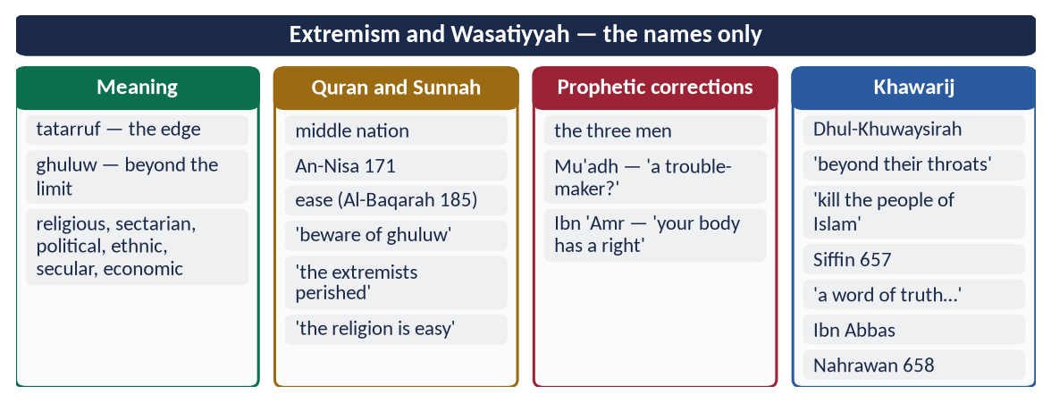
Figure 3 · At a glance — extremism and Wasatiyyah — the names only. The detail is in the sections above.

Chapter 2 · The Rise of Extremism in the Muslim World
The syllabus line itself: 'Rise of extremism'.

2.1 Extremism in Muslim history — before the modern age
- The Khawarij (from 657) — takfir and violence against Muslims (Chapter 1).
- The Qaramitah (Carmathians) — in 317 AH / 930 attacked Makkah during Hajj and carried off the Black Stone for about twenty years.
- The Hashishiyyin (Assassins, 11th–13th c.) — political murder from mountain fortresses.
Each was rejected by the mainstream scholars and community of its time; each ended in failure.

2.2 The modern rise — the causes and turning points
Period | Event | Effect
1916–1924 | Sykes–Picot; the end of the Caliphate | Humiliation; artificial states; loss of a unifying authority
1948, 1967 | The Nakba; occupation of Palestine | A lasting grievance used by every militant movement
1979 | Soviet invasion of Afghanistan | A decade of armed jihad funded from abroad; arms and fighters spread across the region
1979 | Iranian Revolution | Sunni–Shia rivalry turned into regional competition
1988–1990s | Al-Qaeda founded; 'Afghan veterans' return home | Transnational terrorist networks
2001 | 9/11 and the 'War on Terror' | Invasion of Afghanistan; drone strikes; anger and recruitment
2003 | US invasion of Iraq | State collapse; sectarian war; birth of ISIS's forerunner
2011 onwards | Arab Spring; civil war in Syria | Ungoverned spaces
2014–2019 | ISIS (Daesh) declares a 'caliphate' in Iraq and Syria | Global recruitment online; defeated territorially by 2019
2021 | Taliban return to Kabul | Militant groups on Pakistan's border emboldened

2.3 The common roots across the Muslim world
- (a) Ignorance of religion — literal readings without scholars; half-knowledge from pamphlets and the internet.
- (b) Injustice and occupation — Palestine, Kashmir, Iraq; used as recruiting slogans.
- (c) Bad governance — corruption, dictatorship, no peaceful way to change.
- (d) Poverty and unemployment — idle, angry youth.
- (e) Foreign intervention and proxy wars — outside powers arming and funding groups.
- (f) Sectarian rivalry — regional powers backing rival groups.
- (g) The internet — slick propaganda, encrypted recruitment, echo chambers.

2.4 The main extremist groups — know the names
- Al-Qaeda (1988) — transnational jihadist network; 9/11.
- ISIS / Daesh (2014 'caliphate') — extreme takfir; slaughter of Muslims, Yazidis and Christians; defeated territorially in 2017–2019.
- Boko Haram (Nigeria, 2002) — kidnapping of schoolgirls (Chibok, 2014).
- Al-Shabaab (Somalia).
- Tehrik-e-Taliban Pakistan (TTP) (2007) — war against the Pakistani state and people.
All have been condemned by the scholars of the Muslim world — the Amman Message (2004–05), the Letter to Baghdadi (2014, signed by over 120 scholars refuting ISIS point by point), and Paigham-e-Pakistan (2018).

2.5 The evidence that extremism is not Islam
- Its victims are mostly Muslims.
- Its methods are forbidden — suicide, killing women and children, burning people, attacking mosques.
- Its leaders lack scholarly authority — the great institutions (Al-Azhar, the Haramain, the madrasas of all schools in Pakistan) reject them.
- It ends in destruction — Mosul, Raqqa, Swat before 2009.
✦ QURAN
﴿وَإِذَا تَوَلَّىٰ سَعَىٰ فِي ٱلۡأَرۡضِ لِيُفۡسِدَ فِيهَا وَيُهۡلِكَ ٱلۡحَرۡثَ وَٱلنَّسۡلَۚ وَٱللَّهُ لَا يُحِبُّ ٱلۡفَسَادَ﴾
“And when he goes away, he strives throughout the land to cause corruption therein and destroy crops and animals. And Allah does not like corruption.” (Al-Baqarah, Quran)
➜ When he turns away, he strives to cause corruption in the land and destroy crops and life; and Allah does not love corruption.

2.6 Case note — ISIS (Daesh)
- Origins: from the chaos of post-2003 Iraq and the Syrian civil war; proclaimed a 'caliphate' in June 2014 from Mosul.
- Ideology: extreme takfir — declaring most Muslims apostates; revival of slavery; mass executions filmed as propaganda.
- Crimes: genocide against Yazidis (2014); massacres of Muslims; destruction of mosques, shrines, churches and heritage (Palmyra); attacks worldwide.
- Refutation: the Letter to Baghdadi (September 2014), signed by over 120 scholars, refuted its ideology point by point from the Quran and Sunnah; Al-Azhar and the ulema of Pakistan condemned it.
- End: lost Mosul (2017) and its last territory (2019) — a 'caliphate' built on takfir collapsed within five years.

2.7 Case note — Afghanistan and its effects on Pakistan
Four decades of war next door shaped Pakistan's security: refugees (at their peak over 3 million), weapons and drugs in the 1980s; militant sanctuaries after 2001; and, after August 2021, a renewed TTP campaign from across the border. Pakistan's policy has combined dialogue with Kabul, border fencing, refugee repatriation (from 2023) and military action against militant hideouts.

2.8 Why young people join — push and pull factors
Type | Push factors (drive them away from society) | Pull factors (draw them to the group)
Personal | Humiliation, loss of relatives, identity crisis | Belonging, brotherhood, a sense of purpose
Social | Unemployment, poverty, exclusion | Money, marriage, status, weapons
Political | Injustice, corruption, foreign occupation | A promise of 'justice' and 'Islamic rule'
Religious | Ignorance of real Islamic teaching | Simple slogans; promises of Paradise and 'martyrdom'
Digital | Isolation and time online | Slick videos, heroes, secret communities

Effective prevention must reduce the push (justice, jobs, inclusion) and weaken the pull (counter-narrative, true knowledge, attractive alternatives for youth).

2.9 Extremism is not a Muslim monopoly
Extremism grows wherever religion or identity is turned into hatred: white-supremacist terrorism (Oslo and Utøya, 2011; Christchurch, 2019); Hindutva mob violence against Muslims and Christians in India; Buddhist nationalist campaigns against the Rohingya in Myanmar (2017); and, historically, the wars of religion in Europe. Stating this is not an excuse for Muslim extremists — it shows that extremism is a human disease and that the cure — justice, education, dialogue — is universal.
✦ QURAN
﴿… وَلَا يَجۡرِمَنَّكُمۡ شَنَـَٔانُ قَوۡمٍ عَلَىٰٓ أَلَّا تَعۡدِلُواْۚ ٱعۡدِلُواْ هُوَ أَقۡرَبُ لِلتَّقۡوَىٰۖ …﴾
“Do not let the hatred of a people lead you to be unjust. Be just; that is nearer to righteousness.” (Al-Ma'idah, Quran)
➜ Do not let the hatred of a people lead you to injustice — be just; that is nearer to taqwa.

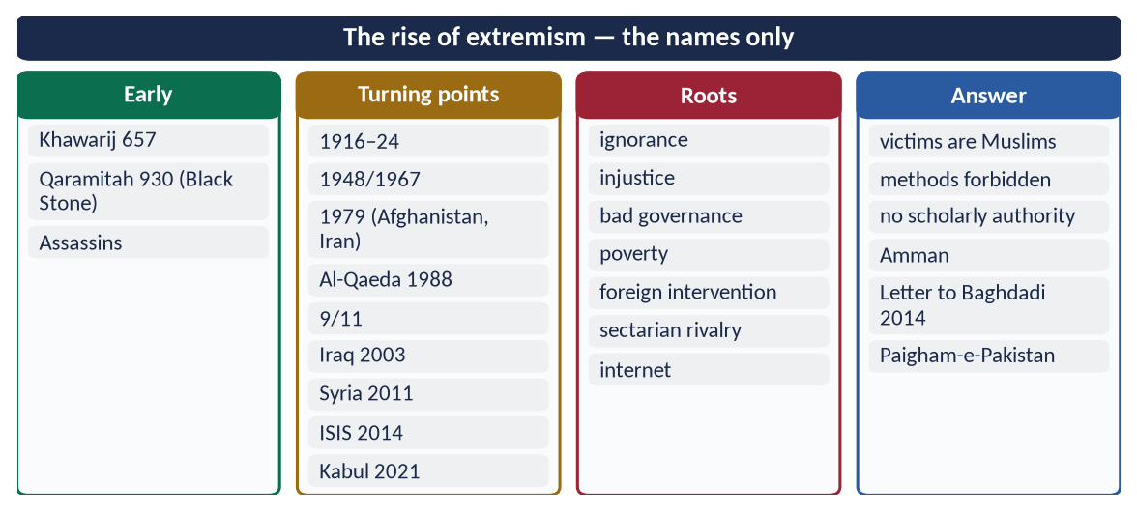
Figure 4 · At a glance — the rise of extremism — the names only. The detail is in the sections above.

Chapter 3 · Extremism and Terrorism in Pakistan: The Motives and Causes
Asked as 'reasons of extremism' (2017), 'motives of terrorism' (2018) and 'motives of extremism' (2023).

3.1 Extremism and terrorism — the difference
- Extremism is a mindset — rigid, intolerant, exclusive.
- Terrorism is violence against civilians or the state to spread fear for a political or ideological aim.
Not every extremist is a terrorist, but every terrorist begins as an extremist. Pakistan's Anti-Terrorism Act (1997) defines terrorism by its acts and aims — creating fear and insecurity.

3.2 The phases of terrorism in Pakistan
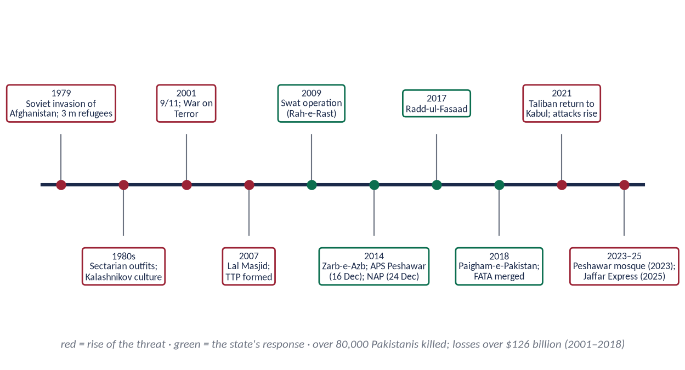
Figure 5 · Terrorism in Pakistan and the state's response, 1979–2025.

(1) The Afghan war legacy (1979–2001)
The Soviet invasion (December 1979) brought about 3 million Afghan refugees, a flood of weapons (the 'Kalashnikov culture'), drugs, and armed groups trained for war. In the 1980s and 1990s sectarian militant organisations emerged and targeted killings began.

(2) After 9/11 (2001–2007)
Pakistan joined the 'War on Terror'; militants fled into the tribal areas; drone strikes (from 2004) caused civilian deaths and anger.

(3) Open war on the state (2007–2014)
The Lal Masjid operation (July 2007) and the formation of the Tehrik-e-Taliban Pakistan (TTP) (December 2007) began a campaign of suicide bombings across the country; Swat fell under militant control until the 2009 operation Rah-e-Rast. Benazir Bhutto was assassinated (27 December 2007).

(4) The turning point (2014–2018)
Operation Zarb-e-Azb (June 2014) in North Waziristan; the massacre at the Army Public School, Peshawar (16 December 2014, about 147 killed); the National Action Plan (24 December 2014); military courts (21st Amendment, 2015); Radd-ul-Fasaad (February 2017); Paigham-e-Pakistan (2018); the merger of FATA with Khyber Pakhtunkhwa (25th Amendment, 2018). Terrorism fell sharply.

(5) The resurgence (2021 onwards)
After the Taliban's return to Kabul (August 2021), TTP attacks rose again; the Peshawar Police Lines mosque bombing (30 January 2023) killed about 100; separatist violence grew in Balochistan, including the hijacking of the Jaffar Express (March 2025). The Global Terrorism Index 2025 ranked Pakistan the second most affected country.

3.3 The reasons and motives — the roots
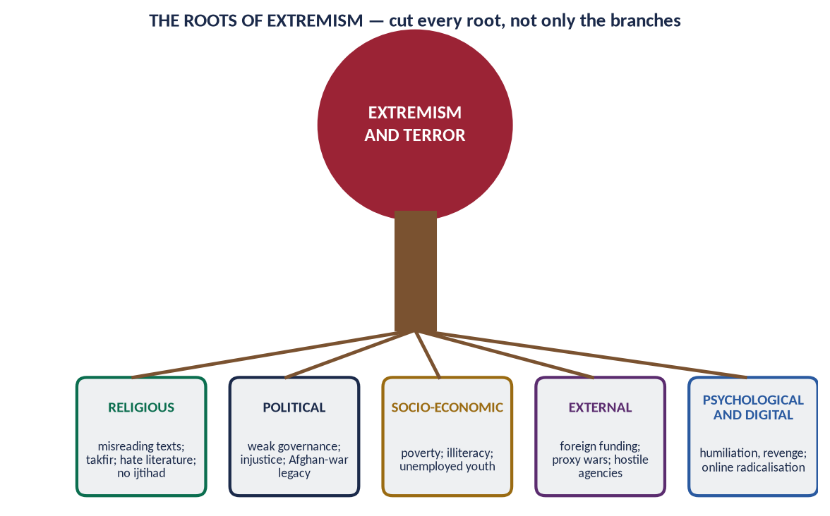
Figure 6 · The five roots of extremism and terrorism.

(1) Religious and ideological
- Misinterpretation of the Quran and Hadith — verses of war taken out of context; ignorance of the jurists' conditions.
- Takfir — declaring the state, the army and ordinary Muslims disbelievers.
- Hate literature and speech — sectarian books, sermons and loudspeakers.
- Misuse of some madrasas by militant groups (a small minority of institutions; the great majority teach peacefully).
- The belief that the Shari'ah must be imposed by force.
✦ QURAN
﴿… فَأَمَّا ٱلَّذِينَ فِي قُلُوبِهِمۡ زَيۡغٞ فَيَتَّبِعُونَ مَا تَشَٰبَهَ مِنۡهُ ٱبۡتِغَآءَ ٱلۡفِتۡنَةِ وَٱبۡتِغَآءَ تَأۡوِيلِهِۦۖ …﴾
“As for those in whose hearts is deviation, they follow what is ambiguous in it, seeking discord and seeking an interpretation of it.” (Aal-e-Imran, Quran)
➜ Those in whose hearts is deviation follow what is ambiguous in it, seeking discord (fitnah) and seeking an interpretation suited to them.

(2) Political
- Weak governance — no writ of the state in some areas (former FATA, parts of Balochistan).
- Injustice and delay — people turn to militants promising 'quick justice' (Swat, 2008).
- Policy legacy — the Afghan jihad era's tolerance of armed groups.
- Political instability and polarisation.

(3) Socio-economic
- Poverty and unemployment — a large, jobless youth population is easy to recruit.
- Illiteracy — over 26 million children out of school; weak understanding of religion.
- Social injustice — land, water, jobs denied to the weak.

(4) External
- Foreign funding of religious and sectarian groups.
- Proxy wars in the region; hostile agencies — Pakistan's government has repeatedly accused India of sponsoring terrorism, pointing to the arrest of the Indian naval officer Kulbhushan Jadhav in Balochistan (2016).
- Afghanistan — safe havens for the TTP across the border.
- Global grievances — Palestine, Kashmir, drone strikes — used in propaganda.

(5) Psychological, social and digital
- Revenge — for relatives killed in military operations or drone strikes.
- Identity crisis and humiliation — the search for meaning and power.
- Online radicalisation — propaganda videos, encrypted chats, echo chambers.
- Glorification — 'martyrdom' propaganda for suicide bombers.

(6) Legal and administrative
- Low conviction rates, witness intimidation, slow trials.
- Terror financing — Pakistan was on the FATF grey list (2018–2022) until it strengthened controls.
- Weak coordination between agencies (NACTA was meant to solve this).

3.3a The cost of terrorism for Pakistan
- Lives: over 80,000 killed (2001–2018), including thousands of soldiers and police.
- Economy: over 126 billion dollars in direct and indirect losses (2001–2018); lost foreign investment and tourism.
- Sport: after the attack on the Sri Lankan cricket team in Lahore (March 2009), international cricket did not return to Pakistan in full for about a decade; its return from 2019 became a symbol of recovery.
- Education: hundreds of schools destroyed, especially in Khyber Pakhtunkhwa and the tribal areas.
- Image: travel warnings, visa difficulties, and the FATF grey list.

3.4 The motives of terrorists (2018)
Motive | Explanation
Ideological | To impose their version of Shari'ah; takfir of the state
Revenge | For military operations, drone strikes, killed relatives
Separatist | Ethnic nationalist groups seeking separation (Balochistan)
Sectarian | Killing members of other schools
Foreign-sponsored | Proxies of hostile states
Criminal-economic | Extortion, kidnapping for ransom, smuggling, drug money
Psychological | Power, belonging, 'martyrdom', fame

3.5 Three case studies

(1) Swat (2007–2009)
Slow and expensive courts, poverty and a vacuum of authority let a militant movement promise 'quick Islamic justice'. It soon closed girls' schools, executed opponents publicly and attacked the state. Operation Rah-e-Rast (2009) displaced over two million people temporarily but restored the writ; courts, schools and tourism returned. Lesson: justice delayed is an opening for extremists.

(2) Karachi (1990s–2013)
Violence here was a mixture of ethnic, sectarian, political and criminal — target killings, extortion and kidnapping. The Karachi operation from 2013 by the Rangers and police sharply reduced it. Lesson: terrorism and organised crime often feed each other.

(3) Balochistan
Separatist violence draws on long-standing grievances — under-development, unequal sharing of resources, and complaints over enforced disappearances — which hostile foreign agencies exploit. Attacks on workers, travellers and projects (including CPEC) have increased. Lesson: security must go with political dialogue, provincial rights (18th Amendment, NFC Award) and development.
✦ QURAN
﴿يَـٰٓأَيُّهَا ٱلَّذِينَ ءَامَنُواْ كُونُواْ قَوَّـٰمِينَ بِٱلۡقِسۡطِ شُهَدَآءَ لِلَّهِ وَلَوۡ عَلَىٰٓ أَنفُسِكُمۡ أَوِ ٱلۡوَٰلِدَيۡنِ وَٱلۡأَقۡرَبِينَۚ …﴾
“O you who believe, stand firmly for justice, as witnesses for Allah, even if it be against yourselves, your parents or your relatives.” (An-Nisa, Quran)
➜ Stand firm for justice, as witnesses for Allah, even against yourselves.

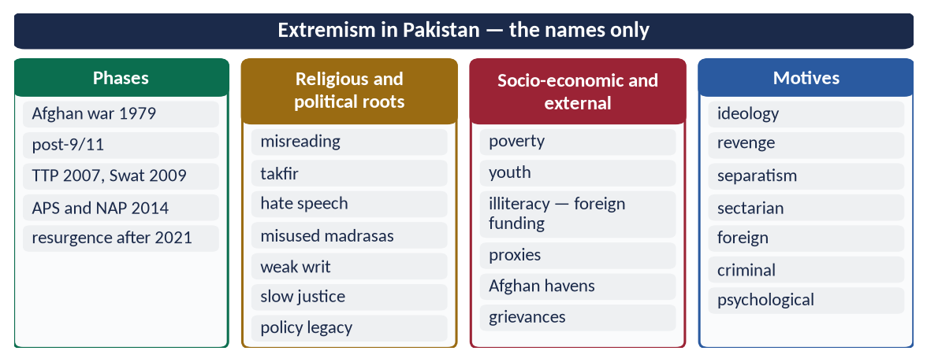
Figure 7 · At a glance — extremism in Pakistan — the names only. The detail is in the sections above.

Chapter 4 · Eliminating Extremism: The Teachings of the Holy Prophet ﷺ and a National Plan
Asked in 2024: 'How is it possible to eliminate the religious and political extremism in Pakistan in the light of the teachings of the Holy Prophet ﷺ?' — and as the second limb of 2017, 2018 and 2023.

4.1 The teachings of the Holy Prophet ﷺ against religious extremism

(1) Ease, not hardship
✦ HADITH
إِنَّ الدِّينَ يُسْرٌ، وَلَنْ يُشَادَّ الدِّينَ أَحَدٌ إِلَّا غَلَبَهُ
“The religion is easy, and no one makes it hard except that it overcomes him.” (Al-Bukhari)

(2) Gentleness in correction
✦ HADITH
إِنَّ اللَّهَ رَفِيقٌ يُحِبُّ الرِّفْقَ فِي الْأَمْرِ كُلِّهِ
“Allah is gentle and loves gentleness in every matter.” (Al-Bukhari and Muslim)

The Bedouin who urinated in the mosque was taught, not beaten (Al-Bukhari).

(3) The sanctity of life
✦ QURAN
﴿… مَن قَتَلَ نَفۡسَۢا بِغَيۡرِ نَفۡسٍ أَوۡ فَسَادٖ فِي ٱلۡأَرۡضِ فَكَأَنَّمَا قَتَلَ ٱلنَّاسَ جَمِيعٗا وَمَنۡ أَحۡيَاهَا فَكَأَنَّمَآ أَحۡيَا ٱلنَّاسَ جَمِيعٗاۚ …﴾
“Whoever kills a soul — unless for a soul or for corruption in the land — it is as if he had slain mankind entirely; and whoever saves one, it is as if he had saved mankind entirely.” (Al-Ma'idah, Quran)
➜ Killing one innocent soul is like killing all mankind.

✦ QURAN
﴿وَمَن يَقۡتُلۡ مُؤۡمِنٗا مُّتَعَمِّدٗا فَجَزَآؤُهُۥ جَهَنَّمُ خَٰلِدٗا فِيهَا وَغَضِبَ ٱللَّهُ عَلَيۡهِ وَلَعَنَهُۥ وَأَعَدَّ لَهُۥ عَذَابًا عَظِيمٗا﴾
“But whoever kills a believer intentionally - his recompense is Hell, wherein he will abide eternally, and Allah has become angry with him and has cursed him and has prepared for him a great punishment.” (An-Nisa, Quran)
➜ Whoever kills a believer intentionally — his recompense is Hell, abiding eternally therein.

✦ HADITH
لَنْ يَزَالَ الْمُؤْمِنُ فِي فُسْحَةٍ مِنْ دِينِهِ مَا لَمْ يُصِبْ دَمًا حَرَامًا
“The believer remains within the scope of his religion as long as he does not shed forbidden blood.” (Al-Bukhari)

(4) No suicide
✦ QURAN
﴿… لَا تَأۡكُلُوٓاْ أَمۡوَٰلَكُم بَيۡنَكُم بِٱلۡبَٰطِلِ إِلَّآ أَن تَكُونَ تِجَٰرَةً عَن تَرَاضٖ مِّنكُمۡۚ …﴾
“Do not consume one another's wealth unjustly, but only in lawful trade by mutual consent.” (An-Nisa, Quran)
➜ 'Do not kill yourselves; Allah is ever Merciful to you.'

✦ HADITH
مَنْ قَتَلَ نَفْسَهُ بِحَدِيدَةٍ فَحَدِيدَتُهُ فِي يَدِهِ يَتَوَجَّأُ بِهَا فِي بَطْنِهِ فِي نَارِ جَهَنَّمَ خَالِدًا مُخَلَّدًا فِيهَا أَبَدًا
“Whoever kills himself with a weapon will hold it in his hand, stabbing his stomach in the Fire of Hell for ever.” (Muslim)
➜ Suicide attacks are doubly forbidden: suicide and murder.

(5) No takfir
✦ QURAN
﴿… إِذَا ضَرَبۡتُمۡ فِي سَبِيلِ ٱللَّهِ فَتَبَيَّنُواْ وَلَا تَقُولُواْ لِمَنۡ أَلۡقَىٰٓ إِلَيۡكُمُ ٱلسَّلَٰمَ لَسۡتَ مُؤۡمِنٗا …﴾
“O you who believe, when you go forth in the cause of Allah, verify, and do not say to one who offers you peace, 'You are not a believer.'” (An-Nisa, Quran)
➜ Do not say to one who offers you peace, 'You are not a believer.'

✦ HADITH
إِذَا قَالَ الرَّجُلُ لِأَخِيهِ يَا كَافِرُ، فَقَدْ بَاءَ بِهِ أَحَدُهُمَا
“When a man says to his brother, 'O disbeliever', it returns to one of them.” (Al-Bukhari)

When Usamah (RA) killed a man who had said 'La ilaha illallah' in battle, thinking he said it from fear, the Prophet ﷺ asked, 'Did you open his heart to see?' (Muslim) — and repeated his rebuke until Usamah wished he had not yet accepted Islam.
✦ HADITH
مَنْ صَلَّى صَلَاتَنَا، وَاسْتَقْبَلَ قِبْلَتَنَا، وَأَكَلَ ذَبِيحَتَنَا، فَذَلِكَ الْمُسْلِمُ
“Whoever prays our prayer, faces our qiblah and eats our slaughtered meat is a Muslim.” (Al-Bukhari)
➜ The outward test — hearts are for Allah.

(6) No armed groups against the Ummah
✦ HADITH
مَنْ حَمَلَ عَلَيْنَا السِّلَاحَ فَلَيْسَ مِنَّا
“Whoever takes up arms against us is not of us.” (Al-Bukhari and Muslim)

✦ HADITH
مَنْ خَرَجَ مِنَ الطَّاعَةِ، وَفَارَقَ الْجَمَاعَةَ فَمَاتَ، مَاتَ مِيتَةً جَاهِلِيَّةً
“Whoever leaves obedience and separates from the community and dies, dies a death of Jahiliyyah.” (Muslim)
➜ Armed rebellion against a lawful state is forbidden.

(7) Correcting wrong the right way
'Whoever sees a wrong, let him change it with his hand; if he cannot, then with his tongue; if he cannot, then with his heart' (Muslim). The jurists explain that 'with the hand' belongs to those with lawful authority — the state in public matters, the parent in the home — not to private groups with weapons. Otherwise the cure becomes a greater evil (fitnah).

(8) Dialogue with those who disagree
The Prophet ﷺ did not punish Dhul-Khuwaysirah for insulting him; Ali (RA) sent Ibn Abbas (RA) to debate the Khawarij, and thousands returned.

4.2 The teachings of the Holy Prophet ﷺ against political extremism

(1) Tolerance of opposition
The Prophet ﷺ tolerated Abdullah ibn Ubayy, the leader of the hypocrites, for years, and refused to kill him: 'People will say Muhammad kills his companions' (Al-Bukhari).

(2) Consultation and respect for differing views
✦ QURAN
﴿وَٱلَّذِينَ ٱسۡتَجَابُواْ لِرَبِّهِمۡ وَأَقَامُواْ ٱلصَّلَوٰةَ وَأَمۡرُهُمۡ شُورَىٰ بَيۡنَهُمۡ وَمِمَّا رَزَقۡنَٰهُمۡ يُنفِقُونَ﴾
“And those who have responded to their lord and established prayer and whose affair is [determined by] consultation among themselves, and from what We have provided them, they spend.” (Ash-Shura, Quran)
➜ Their affairs are by consultation among themselves.

✦ QURAN
﴿فَبِمَا رَحۡمَةٖ مِّنَ ٱللَّهِ لِنتَ لَهُمۡۖ وَلَوۡ كُنتَ فَظًّا غَلِيظَ ٱلۡقَلۡبِ لَٱنفَضُّواْ مِنۡ حَوۡلِكَۖ …﴾
“So by mercy from Allah you were gentle with them; had you been harsh and hard-hearted, they would have scattered from around you.” (Aal-e-Imran, Quran)
➜ By Allah's mercy you were gentle; had you been harsh, they would have scattered.

At Hudaybiyyah, Umar (RA) objected strongly; the Prophet ﷺ answered him with patience, not punishment.

(3) Truthful speech — no propaganda
✦ QURAN
﴿يَـٰٓأَيُّهَا ٱلَّذِينَ ءَامَنُوٓاْ إِن جَآءَكُمۡ فَاسِقُۢ بِنَبَإٖ فَتَبَيَّنُوٓاْ أَن تُصِيبُواْ قَوۡمَۢا بِجَهَٰلَةٖ فَتُصۡبِحُواْ عَلَىٰ مَا فَعَلۡتُمۡ نَٰدِمِينَ﴾
“O you who have believed, if there comes to you a disobedient one with information, investigate, lest you harm a people out of ignorance and become, over what you have done, regretful.” (Al-Hujurat, Quran)
➜ If a sinful person brings you news, verify it.

✦ QURAN
﴿… لَا يَسۡخَرۡ قَوۡمٞ مِّن قَوۡمٍ عَسَىٰٓ أَن يَكُونُواْ خَيۡرٗا مِّنۡهُمۡ وَلَا نِسَآءٞ مِّن نِّسَآءٍ عَسَىٰٓ أَن يَكُنَّ خَيۡرٗا مِّنۡهُنَّۖ …﴾
“Let not a people ridicule another people — perhaps they are better than them; nor let women ridicule other women — perhaps they are better than them.” (Al-Hujurat, Quran)
➜ Do not mock one another or call one another by offensive names.

✦ HADITH
كَفَى بِالْمَرْءِ كَذِبًا أَنْ يُحَدِّثَ بِكُلِّ مَا سَمِعَ
“It is enough of a lie for a man to repeat everything he hears.” (Muslim)
➜ The answer to political fake news.

(4) No harm to public life
✦ HADITH
لَا ضَرَرَ وَلَا ضِرَارَ
“There is to be no harm and no returning of harm.” (Ibn Majah)
➜ Burning property and blocking roads in protest are forbidden.

(5) Justice to opponents
✦ QURAN
﴿… وَلَا يَجۡرِمَنَّكُمۡ شَنَـَٔانُ قَوۡمٍ عَلَىٰٓ أَلَّا تَعۡدِلُواْۚ ٱعۡدِلُواْ هُوَ أَقۡرَبُ لِلتَّقۡوَىٰۖ …﴾
“Do not let the hatred of a people lead you to be unjust. Be just; that is nearer to righteousness.” (Al-Ma'idah, Quran)
➜ Do not let hatred of a people lead you to injustice — be just; that is nearer to taqwa.

(6) A constitution for all
The Charter of Madinah united Muslims, Jews and Arab clans under one agreed law — the model of a pluralist political order (Topic 3).

4.3 A national plan — the state's response

(1) The National Action Plan (NAP), 24 December 2014
Agreed by all parties after the APS massacre; its 20 points include:
# | Main points
1–3 | Execution of convicted terrorists; special (military) courts for two years; no armed militias
4–6 | Strengthening NACTA; action against hate literature and speech; choking terrorist financing
7–9 | Banned outfits not to re-emerge under new names; a counter-terrorism force; action against religious persecution
10–12 | Registration and regulation of madrasas; no glorification of terrorists in media; administrative and development reforms in FATA
13–16 | Dismantling terrorist communication networks; action against terrorism on the internet; Punjab and Karachi operations
17–20 | Reconciliation in Balochistan; action against sectarian terrorists; policy on Afghan refugees; reform of the criminal justice system

(2) Military operations
Rah-e-Rast (Swat, 2009), Zarb-e-Azb (North Waziristan, June 2014), Radd-ul-Fasaad (nationwide, February 2017), and later operations against the resurgence.

(3) Institutions and laws
- NACTA (National Counter Terrorism Authority, statutory since 2013).
- Anti-Terrorism Act 1997 and its amendments; counter-terrorism departments in the provinces.
- National Security Policy (2022) — joining security with economic and human security.
- FATF — exit from the grey list (October 2022) after tightening controls on terror financing.
- FATA merger with Khyber Pakhtunkhwa (25th Amendment, 2018); border fencing with Afghanistan.

(4) Madrasa reform
Registration of madrasas with the Directorate General of Religious Education (from 2019), the teaching of modern subjects, audited funding, and the 2024 amendment on madrasa registration.

(5) De-radicalisation
Centres such as Sabaoon in Swat (from 2009) rehabilitated young people recruited by militants — education, counselling, vocational training.

(6) The counter-narrative
Paigham-e-Pakistan (2018) — the consensus of the ulema (Chapter 8).

4.4 Society's role — how society can get rid of extremism (2018, 2023)
Institution | Its role
The family | Love, time, supervision; teach tolerance and the Prophet's ﷺ mercy; watch the child's online world
The mosque and the ulema | Friday sermons on wasatiyyah; no hate speech; a common code of conduct
Schools and universities | Critical thinking; the Seerah of mercy; civic education; debating clubs
Madrasas | Modern subjects; the ethics of disagreement; registration and transparency
Media and social media | Counter-narratives; no glorification; responsible reporting; digital literacy
Civil society | Youth sports, arts, volunteering; interfaith and inter-sect platforms
The economy | Jobs and skills for the young — idle hands are recruited first
The justice system | Quick trials; witness protection; equal law

✦ QURAN
﴿وَلۡتَكُن مِّنكُمۡ أُمَّةٞ يَدۡعُونَ إِلَى ٱلۡخَيۡرِ وَيَأۡمُرُونَ بِٱلۡمَعۡرُوفِ وَيَنۡهَوۡنَ عَنِ ٱلۡمُنكَرِۚ وَأُوْلَـٰٓئِكَ هُمُ ٱلۡمُفۡلِحُونَ﴾
“And let there be [arising] from you a nation inviting to [all that is] good, enjoining what is right and forbidding what is wrong, and those will be the successful.” (Aal-e-Imran, Quran)
➜ 'Let there be among you a group inviting to good, enjoining right and forbidding wrong' — organised, lawful effort, not private violence.

4.4a Education — the long-term cure
- Curriculum: the Seerah of mercy; the Charter of Madinah; the adab of disagreement; the rights of minorities; civic education; the stories of Pakistan's heroes of peace.
- Method: critical thinking — teaching students to ask for evidence and to verify (Al-Hujurat 6).
- Teachers: training in moderate Islamic teaching and in recognising signs of radicalisation.
- Madrasas and schools together: exchange programmes; common subjects; recognised certificates.

4.4b The role of mothers and women
Mothers are the first teachers; they are often the first to notice a child's change. Women scholars and teachers — like Morocco's murshidat — can reach homes that male preachers cannot. Islam honours this role: 'Paradise is beneath her feet' (Al-Nasa'i).

4.5 Lessons from other Muslim countries
Country | Programme
Saudi Arabia | The Munasaha (advice) programme — scholars, psychologists and families work with detained militants; rehabilitation and reintegration
Indonesia | Former militants engaged as counter-voices; the large mass organisations teach moderate Islam
Morocco | Training of imams and women preachers (murshidat) in moderate, Maliki-based teaching
Malaysia | Rehabilitation with religious counselling; regional cooperation
Jordan | The Amman Message (2004–05) and interfaith initiatives

4.6 Justice and development as counter-terrorism
Terrorism thrives where the state is absent. Quick justice, police reform, jobs, roads, schools and health in neglected areas, and provincial rights remove the grievances that recruiters exploit.
✦ QURAN
﴿إِنَّ ٱللَّهَ يَأۡمُرُ بِٱلۡعَدۡلِ وَٱلۡإِحۡسَٰنِ وَإِيتَآيِٕ ذِي ٱلۡقُرۡبَىٰ وَيَنۡهَىٰ عَنِ ٱلۡفَحۡشَآءِ وَٱلۡمُنكَرِ وَٱلۡبَغۡيِۚ يَعِظُكُمۡ لَعَلَّكُمۡ تَذَكَّرُونَ﴾
“Indeed, Allah orders justice and good conduct and giving to relatives and forbids immorality and bad conduct and oppression. He admonishes you that perhaps you will be reminded.” (An-Nahl, Quran)
➜ Allah commands justice ('adl) and excellence (ihsan), and forbids indecency, wrong and oppression (baghy).

4.7 The Prophetic way with rebels and dissenters
- Dissenters were tolerated and answered with argument (Ibn Ubayy; Dhul-Khuwaysirah).
- Rebels who took up arms were first invited to dialogue (Ali and Ibn Abbas), then fought only as far as needed to end their violence; their wounded were not killed, their fleeing not pursued, their property not taken — the Hanafi law of baghy.
- Those who repented were accepted back.

4.8 The door of repentance — the Islamic basis of rehabilitation
✦ QURAN
﴿إِلَّا ٱلَّذِينَ تَابُواْ مِن قَبۡلِ أَن تَقۡدِرُواْ عَلَيۡهِمۡۖ فَٱعۡلَمُوٓاْ أَنَّ ٱللَّهَ غَفُورٞ رَّحِيمٞ﴾
“Except for those who return [repenting] before you apprehend them. And know that Allah is Forgiving and Merciful.” (Al-Ma'idah, Quran)
➜ Except those who repent before you overpower them — know that Allah is Forgiving, Merciful.

Rehabilitation programmes (Sabaoon; Saudi Munasaha) follow this Quranic principle: those who lay down arms, renounce violence and have not committed the gravest crimes can be reformed and reintegrated; victims' rights to justice and compensation remain.
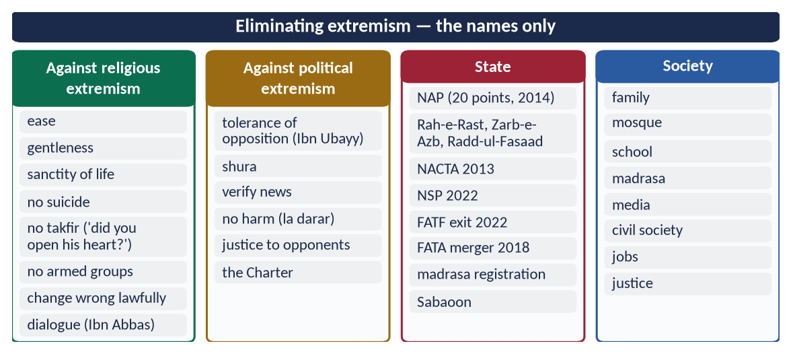
Figure 8 · At a glance — eliminating extremism — the names only. The detail is in the sections above.

Chapter 5 · Sectarianism and Polarisation: Causes and Solutions
Asked in 2026: 'Examine the causes of sectarianism and polarization in the Muslim World. Suggest solutions in the light of Islamic teachings.'

5.1 The meanings
- Difference (ikhtilaf, اِخْتِلَاف) — honest disagreement in interpretation among scholars: natural, often a mercy, and part of Islamic scholarship.
- Sectarianism (firqah-wariyyat, تَفَرُّق) — turning a difference into identity, hatred and conflict: 'my group alone is right, the others are misguided or disbelievers'.
- Polarisation — the division of society into hostile camps — religious, political, ethnic or ideological — that no longer listen to one another.
Islam permits difference but forbids division.

5.2 The Quran on division
✦ QURAN
﴿وَٱعۡتَصِمُواْ بِحَبۡلِ ٱللَّهِ جَمِيعٗا وَلَا تَفَرَّقُواْۚ وَٱذۡكُرُواْ نِعۡمَتَ ٱللَّهِ عَلَيۡكُمۡ إِذۡ كُنتُمۡ أَعۡدَآءٗ فَأَلَّفَ بَيۡنَ قُلُوبِكُمۡ فَأَصۡبَحۡتُم بِنِعۡمَتِهِۦٓ إِخۡوَٰنٗا …﴾
“And hold firmly to the rope of Allah all together and do not become divided. Remember Allah's favour upon you: you were enemies, and He brought your hearts together, and by His favour you became brothers.” (Aal-e-Imran, Quran)
➜ 'Hold fast to the rope of Allah all together and do not be divided.'

✦ QURAN
﴿وَلَا تَكُونُواْ كَٱلَّذِينَ تَفَرَّقُواْ وَٱخۡتَلَفُواْ مِنۢ بَعۡدِ مَا جَآءَهُمُ ٱلۡبَيِّنَٰتُۚ وَأُوْلَـٰٓئِكَ لَهُمۡ عَذَابٌ عَظِيمٞ﴾
“And do not be like the ones who became divided and differed after the clear proofs had come to them. And those will have a great punishment.” (Aal-e-Imran, Quran)
➜ Do not be like those who became divided and differed after clear proofs came to them.

✦ QURAN
﴿إِنَّ ٱلَّذِينَ فَرَّقُواْ دِينَهُمۡ وَكَانُواْ شِيَعٗا لَّسۡتَ مِنۡهُمۡ فِي شَيۡءٍۚ إِنَّمَآ أَمۡرُهُمۡ إِلَى ٱللَّهِ ثُمَّ يُنَبِّئُهُم بِمَا كَانُواْ يَفۡعَلُونَ﴾
“Indeed, those who have divided their religion and become sects - you, [O Muhammad], are not [associated] with them in anything. Their affair is only [left] to Allah; then He will inform them about what they used to do.” (Al-An'am, Quran)
➜ Those who divided their religion and became sects — you have nothing to do with them.

✦ QURAN
﴿وَأَطِيعُواْ ٱللَّهَ وَرَسُولَهُۥ وَلَا تَنَٰزَعُواْ فَتَفۡشَلُواْ وَتَذۡهَبَ رِيحُكُمۡۖ وَٱصۡبِرُوٓاْۚ إِنَّ ٱللَّهَ مَعَ ٱلصَّـٰبِرِينَ﴾
“And obey Allah and His Messenger, and do not dispute and [thus] lose courage and [then] your strength would depart; and be patient. Indeed, Allah is with the patient.” (Al-Anfal, Quran)
➜ Do not dispute, lest you lose courage and your strength departs.

✦ QURAN
﴿شَرَعَ لَكُم مِّنَ ٱلدِّينِ مَا وَصَّىٰ بِهِۦ نُوحٗا وَٱلَّذِيٓ أَوۡحَيۡنَآ إِلَيۡكَ وَمَا وَصَّيۡنَا بِهِۦٓ إِبۡرَٰهِيمَ وَمُوسَىٰ وَعِيسَىٰٓۖ أَنۡ أَقِيمُواْ ٱلدِّينَ وَلَا تَتَفَرَّقُواْ فِيهِۚ …﴾
“He has ordained for you of the Din what He enjoined upon Nuh, what We have revealed to you, and what We enjoined upon Ibrahim, Musa and Isa: 'Establish the Din and do not be divided in it.'” (Ash-Shura, Quran)
➜ 'Establish the religion and do not be divided in it.'

✦ QURAN
﴿إِنَّمَا ٱلۡمُؤۡمِنُونَ إِخۡوَةٞ فَأَصۡلِحُواْ بَيۡنَ أَخَوَيۡكُمۡۚ وَٱتَّقُواْ ٱللَّهَ لَعَلَّكُمۡ تُرۡحَمُونَ﴾
“The believers are but brothers, so make settlement between your brothers. And fear Allah that you may receive mercy.” (Al-Hujurat, Quran)
➜ 'The believers are but brothers, so make peace between your brothers.'

5.3 The Sunnah on division
✦ HADITH
لَا تَرْجِعُوا بَعْدِي كُفَّارًا يَضْرِبُ بَعْضُكُمْ رِقَابَ بَعْضٍ
“Do not become disbelievers after me, striking one another's necks.” (Al-Bukhari and Muslim)
➜ His warning at the Farewell Pilgrimage.

✦ HADITH
سِبَابُ الْمُسْلِمِ فُسُوقٌ، وَقِتَالُهُ كُفْرٌ
“Abusing a Muslim is sinful, and fighting him is (an act of) disbelief.” (Al-Bukhari and Muslim)

✦ HADITH
مَثَلُ الْمُؤْمِنِينَ فِي تَوَادِّهِمْ وَتَرَاحُمِهِمْ وَتَعَاطُفِهِمْ مَثَلُ الْجَسَدِ
“The believers in their love and mercy are like one body.” (Muslim)

5.4 How difference was handled by the Companions and the Imams — the adab of disagreement
- The Companions at Banu Qurayzah: told 'let none pray Asr except at Banu Qurayzah', some prayed on the way, some waited; the Prophet ﷺ blamed neither group (Al-Bukhari) — two readings, both accepted.
- Imam Abu Hanifah and Imam Malik respected each other's knowledge though they differed in method.
- Imam Malik refused Caliph Harun al-Rashid's offer to impose his Muwatta on the whole empire: the Companions had spread to different lands with different knowledge.
- Imam al-Shafi'i, praying near the grave of Abu Hanifah, is reported to have left the qunut out of respect for him.
- A saying attributed to Imam al-Shafi'i: 'My opinion is correct with the possibility of being wrong; the opinion of others is wrong with the possibility of being correct.'
✦ SCHOLARLY VIEW
Imam al-Ghazali · Faysal al-Tafriqah; Al-Iqtisad fi al-I'tiqad
Al-Ghazali warned that declaring people of the qiblah disbelievers is a grave danger; to leave a thousand disbelievers alive by mistake is lighter than to shed the blood of a single Muslim by mistake.
➜ The classical caution against takfir.

5.5 The causes of sectarianism and polarisation in the Muslim world

(1) Historical and political
- Early political disputes (after the Caliphate of Uthman (RA)) hardened over centuries into theological identities.
- Rulers used sectarian divisions to control people.
- Colonial 'divide and rule' — communities counted and separated by sect.

(2) Geopolitical rivalry
- Regional powers backing rival groups since 1979 — in Iraq, Syria, Yemen, Lebanon and Pakistan.
- Proxy wars turned sectarian identity into armed conflict.
- The Saudi–Iran rapprochement brokered in Beijing (March 2023) showed that the rivalry can be managed.

(3) Religious
- Ignorance of the adab of disagreement; half-knowledge.
- Takfir of other schools.
- Hate literature and inflammatory sermons; the misuse of loudspeakers.
- Rigid madrasa curricula that teach only refutation of others.

(4) Social and economic
- Poverty, unemployment and frustration channelled into group hatred.
- Weak rule of law — target killings go unpunished.

(5) Media and digital
- Social media echo chambers — algorithms reward outrage.
- Fake videos and quotes spread in minutes.

(6) Political polarisation
- Party politics built on hatred of opponents; the language of 'traitor' and 'infidel' in political speech.
- Loss of trust in institutions; street violence.

5.5a The cost of sectarian conflict in the Muslim world
Sectarian wars in Iraq (from 2003), Syria (from 2011) and Yemen (from 2014–15) have killed hundreds of thousands and displaced millions; mosques and shrines of every school have been bombed; the Muslim world's resources were spent fighting itself while Palestine and Kashmir waited. The Quran's warning came true:
✦ QURAN
﴿وَأَطِيعُواْ ٱللَّهَ وَرَسُولَهُۥ وَلَا تَنَٰزَعُواْ فَتَفۡشَلُواْ وَتَذۡهَبَ رِيحُكُمۡۖ وَٱصۡبِرُوٓاْۚ إِنَّ ٱللَّهَ مَعَ ٱلصَّـٰبِرِينَ﴾
“And obey Allah and His Messenger, and do not dispute and [thus] lose courage and [then] your strength would depart; and be patient. Indeed, Allah is with the patient.” (Al-Anfal, Quran)
➜ 'Do not dispute, lest you lose courage and your strength departs.'

5.6 Sectarianism in Pakistan
- 1980s–1990s — sectarian militant outfits formed; waves of target killings of doctors, lawyers and scholars of different schools; several outfits were later banned.
- Hotspots — Karachi, Quetta, Jhang, Gilgit-Baltistan, Kurram (clashes and the attack on a passenger convoy in November 2024, which killed over 40).
- Hate speech — pamphlets, sermons, social media.
- The response: the Milli Yakjehti Council (1995) of religious parties of all schools; codes of conduct for Muharram and other occasions; Paigham-e-Pakistan (2018); laws against hate speech (PPC 153-A, 295-A, the Anti-Terrorism Act 1997); provincial laws regulating loudspeakers (for example, the Punjab Sound Systems (Regulation) Act 2015).

5.7 The solutions in the light of Islamic teachings

(1) Unity on the fundamentals
Tawhid, Risalah, Akhirah, the Quran, the qiblah and the pillars — shared by all schools.
✦ QURAN
﴿وَٱعۡتَصِمُواْ بِحَبۡلِ ٱللَّهِ جَمِيعٗا وَلَا تَفَرَّقُواْۚ وَٱذۡكُرُواْ نِعۡمَتَ ٱللَّهِ عَلَيۡكُمۡ إِذۡ كُنتُمۡ أَعۡدَآءٗ فَأَلَّفَ بَيۡنَ قُلُوبِكُمۡ فَأَصۡبَحۡتُم بِنِعۡمَتِهِۦٓ إِخۡوَٰنٗا …﴾
“And hold firmly to the rope of Allah all together and do not become divided. Remember Allah's favour upon you: you were enemies, and He brought your hearts together, and by His favour you became brothers.” (Aal-e-Imran, Quran)
➜ 'Hold fast to the rope of Allah all together.'

(2) The adab of disagreement
Respect for all recognised schools of fiqh; debate in the best manner (An-Nahl 125); no insult to revered personalities of any school.

(3) No takfir
✦ QURAN
﴿… إِذَا ضَرَبۡتُمۡ فِي سَبِيلِ ٱللَّهِ فَتَبَيَّنُواْ وَلَا تَقُولُواْ لِمَنۡ أَلۡقَىٰٓ إِلَيۡكُمُ ٱلسَّلَٰمَ لَسۡتَ مُؤۡمِنٗا …﴾
“O you who believe, when you go forth in the cause of Allah, verify, and do not say to one who offers you peace, 'You are not a believer.'” (An-Nisa, Quran)
➜ Do not say to one who offers you peace, 'You are not a believer.'

The Amman Message (2004–2005) — endorsed by some 200 leading scholars from over 50 countries — recognised eight schools of law (the four Sunni schools, the Ja'fari, Zaydi, Ibadi and Zahiri), and forbade declaring any of their followers disbelievers.

(4) Reconciliation
✦ QURAN
﴿وَإِن طَآئِفَتَانِ مِنَ ٱلۡمُؤۡمِنِينَ ٱقۡتَتَلُواْ فَأَصۡلِحُواْ بَيۡنَهُمَاۖ …﴾
“And if two groups of the believers fight, then make peace between them.” (Al-Hujurat, Quran)
➜ If two groups of believers fight, make peace between them — with justice.

Joint councils of ulema; mediation in local disputes (as in Kurram).

(5) Education
Curricula that teach the Seerah of mercy, the history of the Imams' mutual respect, and critical thinking; madrasa courses on comparative fiqh with respect.

(6) Law and governance
Strict enforcement against hate speech and sectarian violence; justice for victims; a ban on armed groups (NAP).

(7) Media and social media
Codes against hate; fact-checking; content that shows scholars of different schools together.

(8) Against political polarisation
Dialogue among parties; respect for election results and courts; truthful speech (Al-Hujurat 6, 11); a charter of democracy and conduct.

(9) Muslim world level
The OIC as a platform of dialogue; an end to proxy wars; the Saudi–Iran détente as a model.

5.8 What all Muslims share
One Allah; one Prophet ﷺ, the last; one Quran; one qiblah; five daily prayers; the fast of Ramadan; Zakat; Hajj; belief in the angels, the Books, the Messengers, the Last Day and destiny; love of the Prophet's ﷺ family and Companions. What unites is far greater than what divides.
✦ QURAN
﴿إِنَّ هَٰذِهِۦٓ أُمَّتُكُمۡ أُمَّةٗ وَٰحِدَةٗ وَأَنَا۠ رَبُّكُمۡ فَٱعۡبُدُونِ﴾
“Indeed this, your religion, is one religion, and I am your Lord, so worship Me.” (Al-Anbiya, Quran)
➜ 'This Ummah of yours is one Ummah, and I am your Lord, so worship Me.'

5.9 Political polarisation in Pakistan
Recent years have seen sharp polarisation — hate speech between party supporters, abuse on social media, attacks on institutions, and distrust of elections and courts. The Prophetic principles apply to politics as much as religion: verify news (Al-Hujurat 6), no mockery or abusive names (Al-Hujurat 11), justice to opponents (Al-Ma'idah 8), consultation (Ash-Shura 38), and no harm to public life ('la darar wa la dirar'). A charter of political conduct, respect for constitutional institutions and a responsible media are the practical remedies.

5.10 Case note — Kurram and the way of the jirga
In Kurram district, land disputes between tribes of different schools repeatedly turned into sectarian fighting; after the attack on a passenger convoy in November 2024 and the fighting that followed, a grand jirga of elders from both sides, with the provincial government, agreed a peace agreement (January 2025) — surrender of heavy weapons, removal of bunkers, reopening of roads and compensation. Lesson: local reconciliation (islah dhat al-bayn), backed by the state, is the Quranic method:
✦ HADITH
أَلَا أُخْبِرُكُمْ بِأَفْضَلَ مِنْ دَرَجَةِ الصِّيَامِ وَالصَّلَاةِ وَالصَّدَقَةِ؟ ... صَلَاحُ ذَاتِ الْبَيْنِ
“Shall I not tell you of something higher in rank than fasting, prayer and charity? … Reconciling between people.” (Abu Dawud and Al-Tirmidhi)

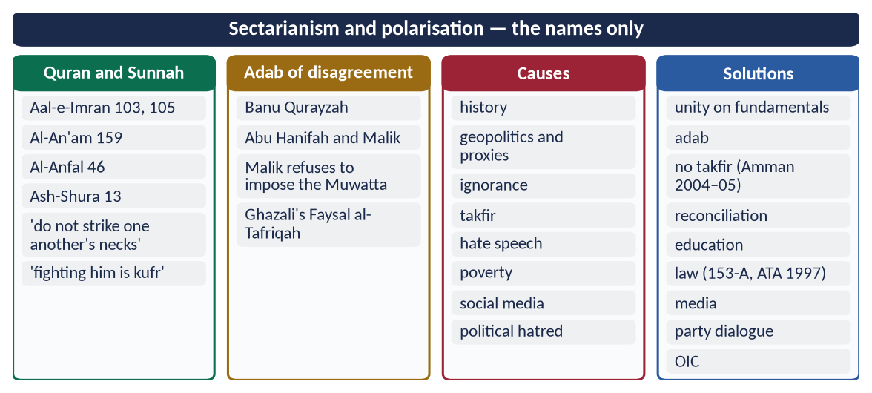
Figure 9 · At a glance — sectarianism and polarisation — the names only. The detail is in the sections above.

Chapter 6 · Jihad: Concept, Kinds, Principles and Conditions
Asked in 2020: 'Discuss in detail the principles and terms & conditions for Jihad in the light of Quran and Sunnah.'

6.1 The meaning of Jihad

(1) Literal meaning
Jihad (جِهَاد) comes from juhd — effort, and jahd — hardship: striving to the utmost.

(2) Technical meaning
Jihad is striving with one's self, wealth, word and — when lawful — life, to make the word of Allah supreme, to establish justice and to defend the Muslim community. Qital (armed fighting) is only one part of it.
✦ HADITH
مَنْ قَاتَلَ لِتَكُونَ كَلِمَةُ اللَّهِ هِيَ الْعُلْيَا فَهُوَ فِي سَبِيلِ اللَّهِ
“Whoever fights so that the word of Allah is supreme, he is in the way of Allah.” (Al-Bukhari and Muslim)
➜ Asked about fighting for booty, for fame or for courage — only the pure intention counts.

6.2 The kinds of Jihad
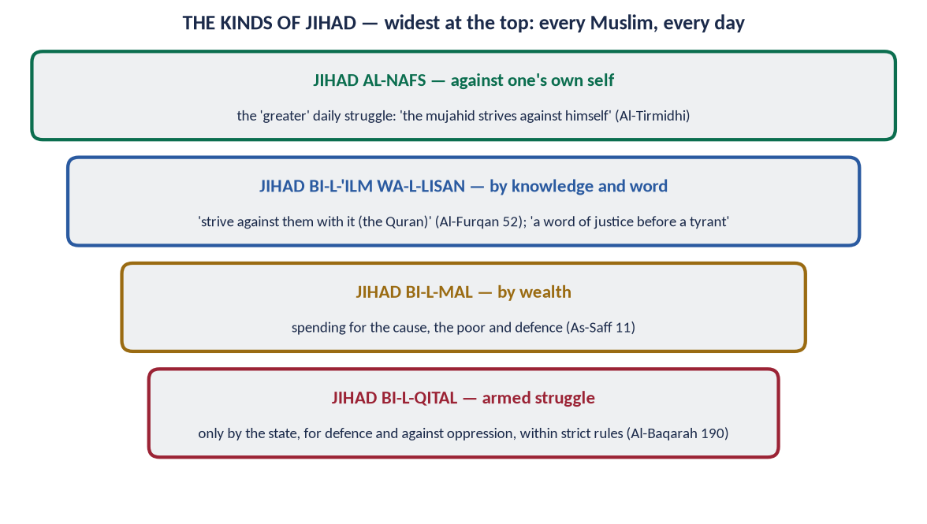
Figure 10 · The kinds of Jihad — the struggle of every Muslim, every day, and armed struggle only under the state.

(1) Jihad against the self (jihad al-nafs)
✦ HADITH
الْمُجَاهِدُ مَنْ جَاهَدَ نَفْسَهُ
“The true mujahid is the one who strives against his own self.” (Al-Tirmidhi)

✦ QURAN
﴿وَٱلَّذِينَ جَٰهَدُواْ فِينَا لَنَهۡدِيَنَّهُمۡ سُبُلَنَاۚ وَإِنَّ ٱللَّهَ لَمَعَ ٱلۡمُحۡسِنِينَ﴾
“And those who strive for Us - We will surely guide them to Our ways. And indeed, Allah is with the doers of good.” (Al-Ankabut, Quran)
➜ 'Those who strive for Us — We will surely guide them to Our ways.'

(2) Jihad by knowledge and the word
✦ QURAN
﴿فَلَا تُطِعِ ٱلۡكَٰفِرِينَ وَجَٰهِدۡهُم بِهِۦ جِهَادٗا كَبِيرٗا﴾
“So do not obey the disbelievers, and strive against them with the Qur'an a great striving.” (Al-Furqan, Quran)
➜ Do not obey the disbelievers, but strive against them with it (the Quran) a great striving.

✦ HADITH
أَفْضَلُ الْجِهَادِ كَلِمَةُ عَدْلٍ عِنْدَ سُلْطَانٍ جَائِرٍ
“The best jihad is a word of justice before a tyrant ruler.” (Abu Dawud and Al-Tirmidhi)

(3) Jihad by wealth
✦ QURAN
﴿تُؤۡمِنُونَ بِٱللَّهِ وَرَسُولِهِۦ وَتُجَٰهِدُونَ فِي سَبِيلِ ٱللَّهِ بِأَمۡوَٰلِكُمۡ وَأَنفُسِكُمۡۚ ذَٰلِكُمۡ خَيۡرٞ لَّكُمۡ إِن كُنتُمۡ تَعۡلَمُونَ﴾
“[It is that] you believe in Allah and His Messenger and strive in the cause of Allah with your wealth and your lives. That is best for you, if you should know.” (As-Saf, Quran)
➜ Believe in Allah and His Messenger and strive in His cause with your wealth and your lives.

(4) Jihad by fighting (qital)
Armed struggle — for defence and against oppression — under strict conditions (6.4).

(5) Other forms in the Sunnah
- Service of parents: a man asked to go for jihad; the Prophet ﷺ asked, 'Are your parents alive?' — 'Yes.' — 'Then strive in (serving) them' (Al-Bukhari).
- Hajj for women: 'the best jihad for you is an accepted Hajj' (Al-Bukhari).

6.3 The stages of the command to fight
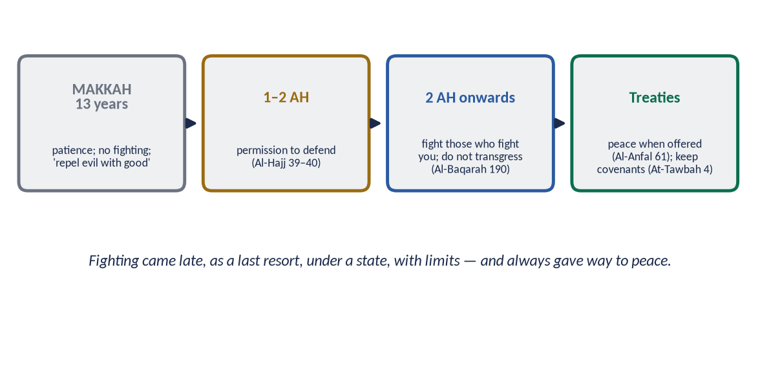
Figure 11 · The stages: patience in Makkah, permission, defence, treaties.
- Makkah (13 years): no fighting, only patience — 'repel evil with what is better' (Fussilat 34).
- Permission (1–2 AH): 'Permission has been given to those who are fought against, because they were wronged' (Al-Hajj 39).
- Defensive fighting: 'Fight in the way of Allah those who fight you, but do not transgress' (Al-Baqarah 190).
- General war against aggressors: 'fight them all together as they fight you all together' (At-Tawbah 36) — reciprocity.
- Peace when offered: 'If they incline to peace, incline to it' (Al-Anfal 61).
✦ QURAN
﴿كُتِبَ عَلَيۡكُمُ ٱلۡقِتَالُ وَهُوَ كُرۡهٞ لَّكُمۡۖ …﴾
“Fighting has been prescribed for you, though it is hateful to you.” (Al-Baqarah, Quran)
➜ 'Fighting has been prescribed for you, though it is hateful to you' — war is never loved for its own sake.

6.4 The principles and conditions of Jihad (qital)

(1) A lawful authority — the state
Armed jihad is declared and led by the state (the imam), not by private groups.
✦ HADITH
إِنَّمَا الْإِمَامُ جُنَّةٌ يُقَاتَلُ مِنْ وَرَائِهِ وَيُتَّقَى بِهِ
“The ruler is a shield: one fights behind him and is protected by him.” (Al-Bukhari and Muslim)

The Hanafi jurists — Imam Muhammad al-Shaybani (d. 805) in Kitab al-Siyar al-Kabir, explained by Al-Sarakhsi — made the declaration and conduct of war the business of the imam. Paigham-e-Pakistan (2018): only the state may declare jihad.

(2) A just cause
- Defence against aggression (Al-Baqarah 190; Al-Hajj 39).
- Ending persecution (fitnah) (Al-Baqarah 193).
- Protecting the oppressed (An-Nisa 75).
- Protecting freedom of worship — monasteries, churches, synagogues and mosques (Al-Hajj 40).
Not for land, wealth, revenge or forced conversion — 'no compulsion in religion' (Al-Baqarah 256).

(3) The right intention
'So that the word of Allah is supreme' — not booty, fame or tribal pride (Al-Bukhari and Muslim).

(4) Invitation and warning before fighting
The Prophet ﷺ instructed his commanders to first offer Islam, or a treaty, or peace, and only then to fight (Muslim, the hadith of Buraydah).

(5) Honouring treaties
✦ QURAN
﴿وَإِمَّا تَخَافَنَّ مِن قَوۡمٍ خِيَانَةٗ فَٱنۢبِذۡ إِلَيۡهِمۡ عَلَىٰ سَوَآءٍۚ إِنَّ ٱللَّهَ لَا يُحِبُّ ٱلۡخَآئِنِينَ﴾
“If you [have reason to] fear from a people betrayal, throw [their treaty] back to them, [putting you] on equal terms. Indeed, Allah does not like traitors.” (Al-Anfal, Quran)
➜ If you fear betrayal from a people, openly declare the treaty ended — not a surprise attack while at peace.

✦ QURAN
﴿… وَإِنِ ٱسۡتَنصَرُوكُمۡ فِي ٱلدِّينِ فَعَلَيۡكُمُ ٱلنَّصۡرُ …﴾
“And if they seek your help in the matter of religion, then it is your duty to help them.” (Al-Anfal, Quran)
➜ Help your fellow believers — except against a people with whom you have a treaty.

(6) Protecting non-combatants
✦ HADITH
اغْزُوا بِاسْمِ اللَّهِ ... وَلَا تَغُلُّوا، وَلَا تَغْدِرُوا، وَلَا تَمْثُلُوا، وَلَا تَقْتُلُوا وَلِيدًا
“Fight in the name of Allah … do not steal from the spoils, do not betray, do not mutilate, do not kill a child.” (Muslim)

✦ HADITH
فَنَهَى رَسُولُ اللَّهِ ﷺ عَنْ قَتْلِ النِّسَاءِ وَالصِّبْيَانِ
“The Messenger of Allah ﷺ forbade the killing of women and children.” (Al-Bukhari and Muslim)

Abu Bakr (RA) added: no old men, no monks in their cells, no cutting of fruit trees, no destruction of buildings (Muwatta).

(7) Proportionality — no transgression
✦ QURAN
﴿وَقَٰتِلُواْ فِي سَبِيلِ ٱللَّهِ ٱلَّذِينَ يُقَٰتِلُونَكُمۡ وَلَا تَعۡتَدُوٓاْۚ إِنَّ ٱللَّهَ لَا يُحِبُّ ٱلۡمُعۡتَدِينَ﴾
“Fight in the way of Allah those who fight you but do not transgress. Indeed. Allah does not like transgressors.” (Al-Baqarah, Quran)
➜ Fight those who fight you, but do not transgress; Allah does not love transgressors.

(8) Humane treatment of prisoners
✦ QURAN
﴿… فَإِمَّا مَنَّۢا بَعۡدُ وَإِمَّا فِدَآءً حَتَّىٰ تَضَعَ ٱلۡحَرۡبُ أَوۡزَارَهَاۚ …﴾
“… then either free them as a favour or for ransom, until the war lays down its burdens.” (Muhammad, Quran)
➜ … then either free them as a favour or for ransom, until the war lays down its burdens.

✦ QURAN
﴿وَيُطۡعِمُونَ ٱلطَّعَامَ عَلَىٰ حُبِّهِۦ مِسۡكِينٗا وَيَتِيمٗا وَأَسِيرًا﴾
“And they give food in spite of love for it to the needy, the orphan, and the captive.” (Al-Insan, Quran)
➜ They give food, though they love it, to the poor, the orphan and the captive.

(9) Peace whenever offered
✦ QURAN
﴿وَإِن جَنَحُواْ لِلسَّلۡمِ فَٱجۡنَحۡ لَهَا وَتَوَكَّلۡ عَلَى ٱللَّهِۚ إِنَّهُۥ هُوَ ٱلسَّمِيعُ ٱلۡعَلِيمُ﴾
“And if they incline to peace, then incline to it [also] and rely upon Allah. Indeed, it is He who is the Hearing, the Knowing.” (Al-Anfal, Quran)
➜ 'If they incline to peace, incline to it and rely upon Allah.'

(10) Individual conditions
- Fard kifayah normally (Hanafi) — a collective duty fulfilled by the army; it becomes fard 'ayn only when the state calls a general mobilisation against an invading enemy.
- Permission of parents for voluntary service (Al-Bukhari).
- Capacity — adulthood, sanity, health.
- Preparation — 'prepare whatever strength you can' (Al-Anfal 60).
Principle | Evidence
Authority of the state | 'The ruler is a shield' (Al-Bukhari and Muslim); Shaybani's Siyar
Just cause | Al-Hajj 39–40; Al-Baqarah 190, 193; An-Nisa 75
Right intention | 'That the word of Allah be supreme'
Invitation first | Hadith of Buraydah (Muslim)
Treaties honoured | Al-Anfal 58, 72
Non-combatants safe | No women, children, old, monks (Muslim; Muwatta)
No transgression | Al-Baqarah 190
Prisoners | Muhammad 4; Al-Insan 8
Peace | Al-Anfal 61

6.4a Jihad in the Constitution and law of Pakistan
- Article 245 — the armed forces defend Pakistan under the direction of the Federal Government.
- Article 256 — 'No private organisation capable of functioning as a military organisation shall be formed'; such an organisation is illegal.
- The Anti-Terrorism Act 1997 — proscription of militant organisations.
These laws reflect the Islamic rule that armed jihad belongs to the state — confirmed by Paigham-e-Pakistan.

6.5 The Islamic laws of war and the Geneva Conventions
Rule | Islamic law (7th–8th c.) | Geneva Conventions (1949) and Protocols (1977)
Distinction | No women, children, old, monks (Muslim; Muwatta) | Civilians may not be targeted
Proportionality | 'Do not transgress' (Al-Baqarah 190) | No excessive harm to civilians
Prisoners | Fed; freed or ransomed (Muhammad 4; Al-Insan 8) | Third Convention: humane treatment
No perfidy | 'Do not betray' (Muslim); treaties honoured | Perfidy prohibited
Property and environment | No cutting of fruit trees, no destruction of towns (Abu Bakr) | Protection of civilian objects and the environment
Envoys | 'Envoys are not killed' (Abu Dawud) | Diplomatic protection

Imam Muhammad al-Shaybani's Siyar (8th century) set out these rules in a legal system a thousand years before the Geneva Conventions — which is why he is called the father of Islamic international law.

6.6 Martyrdom (shahadah) — and why suicide is not martyrdom
✦ QURAN
﴿وَلَا تَحۡسَبَنَّ ٱلَّذِينَ قُتِلُواْ فِي سَبِيلِ ٱللَّهِ أَمۡوَٰتَۢاۚ بَلۡ أَحۡيَآءٌ عِندَ رَبِّهِمۡ يُرۡزَقُونَ﴾
“And never think of those who have been killed in the cause of Allah as dead. Rather, they are alive with their Lord, receiving provision.” (Aal-e-Imran, Quran)
➜ Do not think of those killed in the way of Allah as dead; they are alive with their Lord, receiving provision.

Martyrdom is granted to one who falls in a lawful struggle, with a pure intention, by the enemy's hand. The hadith also counts as martyrs those who die of plague, drowning, fire, childbirth or defending their property (Al-Bukhari and Muslim). A suicide bomber who kills himself and innocent people commits two of the gravest sins — suicide and murder — and cannot be called a martyr.

6.7 The Makkan lesson — restraint under persecution
For thirteen years the Muslims were tortured and killed — Sumayyah (RA), the first martyr of Islam; Yasir (RA); Bilal (RA) under the stones of the desert — yet the Prophet ﷺ did not permit armed revenge. He said to the family of Yasir: 'Be patient, O family of Yasir; your promised place is Paradise' (Al-Hakim). Armed struggle came only when there was a state in Madinah. The lesson for today: individuals and groups do not declare war; patience, lawful struggle and the state are the Islamic way.
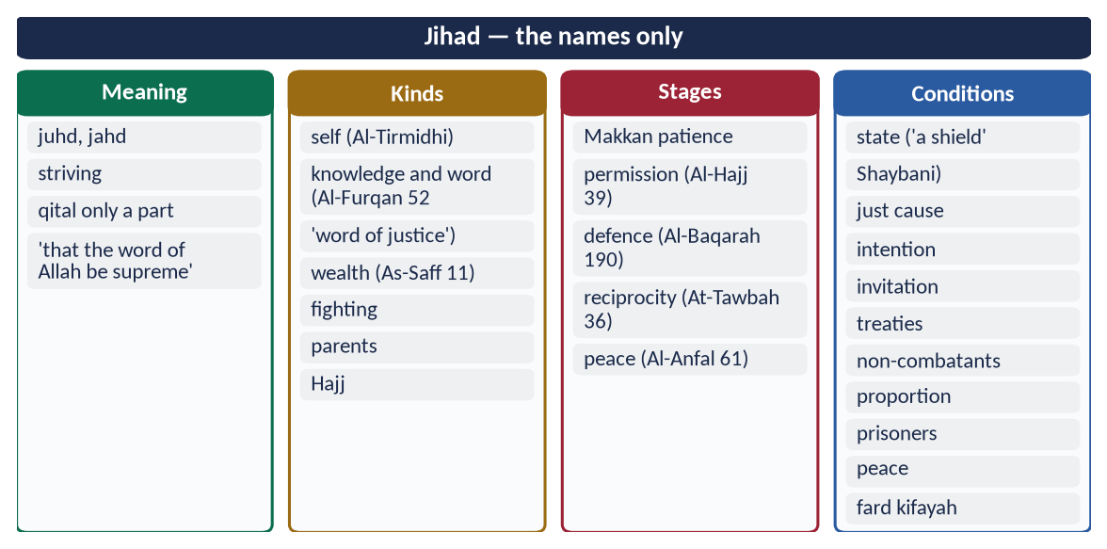
Figure 12 · At a glance — jihad — the names only. The detail is in the sections above.

Chapter 7 · Jihad and Fasad: Jihad in the Present International Scenario
Asked in 2015: 'What is the difference between Jihad and Fasaad? Discuss the possibilities of practical application of the Quranic concept of Jihad in current international scenario.'

7.1 The meaning of Fasad
Fasad (فَسَاد) means corruption, disorder and mischief — spoiling what Allah made sound: life, property, peace, the environment and society.
✦ QURAN
﴿وَإِذَا قِيلَ لَهُمۡ لَا تُفۡسِدُواْ فِي ٱلۡأَرۡضِ قَالُوٓاْ إِنَّمَا نَحۡنُ مُصۡلِحُونَ ۝ أَلَآ إِنَّهُمۡ هُمُ ٱلۡمُفۡسِدُونَ وَلَٰكِن لَّا يَشۡعُرُونَ﴾
“And when it is said to them, "Do not cause corruption on the earth," they say, "We are but reformers. Unquestionably, it is they who are the corrupters, but they perceive [it] not.” (Al-Baqarah, Quran)
➜ When they are told, 'Do not spread corruption in the land,' they say, 'We are only reformers.' Indeed, it is they who are the corrupters, but they do not perceive it.

✦ QURAN
﴿وَلَا تُفۡسِدُواْ فِي ٱلۡأَرۡضِ بَعۡدَ إِصۡلَٰحِهَا وَٱدۡعُوهُ خَوۡفٗا وَطَمَعًاۚ إِنَّ رَحۡمَتَ ٱللَّهِ قَرِيبٞ مِّنَ ٱلۡمُحۡسِنِينَ﴾
“And cause not corruption upon the earth after its reformation. And invoke Him in fear and aspiration. Indeed, the mercy of Allah is near to the doers of good.” (Al-A'raf, Quran)
➜ 'Do not cause corruption in the land after it has been set right.'

✦ QURAN
﴿وَٱبۡتَغِ فِيمَآ ءَاتَىٰكَ ٱللَّهُ ٱلدَّارَ ٱلۡأٓخِرَةَۖ وَلَا تَنسَ نَصِيبَكَ مِنَ ٱلدُّنۡيَاۖ وَأَحۡسِن كَمَآ أَحۡسَنَ ٱللَّهُ إِلَيۡكَۖ وَلَا تَبۡغِ ٱلۡفَسَادَ فِي ٱلۡأَرۡضِۖ …﴾
“Seek, through what Allah has given you, the home of the Hereafter, and do not forget your share of this world; do good as Allah has done good to you, and do not seek corruption in the land.” (Al-Qasas, Quran)
➜ 'Do not seek corruption in the land; Allah does not love the corrupters.'

Terrorism as hirabah
✦ QURAN
﴿إِنَّمَا جَزَـٰٓؤُاْ ٱلَّذِينَ يُحَارِبُونَ ٱللَّهَ وَرَسُولَهُۥ وَيَسۡعَوۡنَ فِي ٱلۡأَرۡضِ فَسَادًا …﴾
“The recompense of those who wage war against Allah and His Messenger and strive to spread corruption (fasad) in the land …” (Al-Ma'idah, Quran)
➜ The recompense of those who wage war against Allah and His Messenger and strive to spread fasad in the land …

The jurists call this crime hirabah — armed attacks that terrorise the public. Many modern scholars classify terrorism under hirabah — the most serious crime against society — not under jihad.

7.2 The difference between Jihad and Fasad
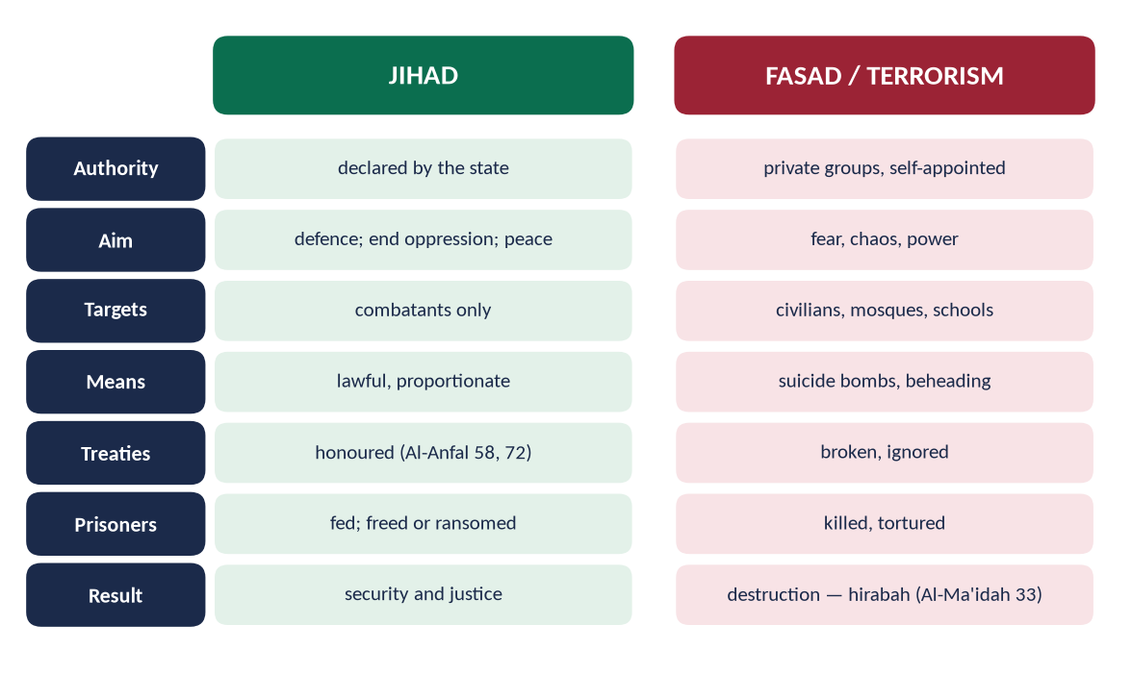
Figure 13 · Jihad and Fasad compared.
Point | Jihad | Fasad / terrorism
Authority | Declared by the state | Private groups, self-appointed
Aim | Defence; ending oppression; peace | Fear, chaos, power
Targets | Combatants only | Civilians, mosques, schools, markets
Means | Lawful and proportionate | Suicide bombing, beheading, kidnapping
Treaties | Honoured (Al-Anfal 58, 72) | Broken
Prisoners | Fed; freed or ransomed | Killed, tortured
Intention | The word of Allah; justice | Revenge, ideology, money
Result | Security and justice | Destruction and disorder
Quranic label | 'In the way of Allah' | Hirabah — war on society (Al-Ma'idah 33)

7.3 The practical application of Jihad in the current international scenario

(1) Defensive jihad by the state
Every state has the right of self-defence — recognised by Article 51 of the UN Charter. Pakistan's armed forces defend the country; deterrence (Al-Anfal 60) prevents war.
✦ QURAN
﴿وَأَعِدُّواْ لَهُم مَّا ٱسۡتَطَعۡتُم مِّن قُوَّةٖ وَمِن رِّبَاطِ ٱلۡخَيۡلِ تُرۡهِبُونَ بِهِۦ عَدُوَّ ٱللَّهِ وَعَدُوَّكُمۡ …﴾
“Prepare against them whatever you are able of power and of steeds of war, by which you may deter the enemy of Allah and your enemy.” (Al-Anfal, Quran)
➜ Prepare whatever strength you can to deter the enemy.

(2) Struggles for freedom and against occupation
International law recognises the right of peoples under colonial or foreign occupation to struggle for self-determination (UN General Assembly Resolution 37/43, 1982). Kashmiris and Palestinians have this right — but the Islamic rules still apply: no targeting of civilians.

(3) Jihad of the pen and the word
Scholarship, media, diplomacy and legal advocacy — at the UN, the ICJ and human-rights forums — for Palestine, Kashmir and the Rohingya.
✦ QURAN
﴿فَلَا تُطِعِ ٱلۡكَٰفِرِينَ وَجَٰهِدۡهُم بِهِۦ جِهَادٗا كَبِيرٗا﴾
“So do not obey the disbelievers, and strive against them with the Qur'an a great striving.” (Al-Furqan, Quran)
➜ 'Strive against them with it (the Quran) a great striving.'

(4) Jihad against ignorance, poverty and disease
Education, science and technology; Zakat and welfare; health care — the greatest needs of the Ummah today.

(5) Jihad against corruption and injustice
'A word of justice before a tyrant ruler' (Abu Dawud) — accountability, rule of law, honest governance.

(6) Jihad against the self
Tazkiyah — the purification that makes all other jihad possible (Topic 5).

(7) Economic and technological jihad
Self-reliance in defence production, energy and technology — strength that deters without war.

(8) Information jihad
Countering Islamophobia and fake narratives with truth — responsibly, 'in the best way' (An-Nahl 125).

7.4 What is not jihad today
- Attacks by private groups without state authority.
- Suicide bombings and attacks on civilians anywhere.
- Rebellion against Muslim states.
- Takfir of Muslims to justify killing them.
All are fasad and hirabah — as Paigham-e-Pakistan declared.

7.5 Verses misused by extremists — read in context
Verse | How it is misused | Its context and meaning
At-Tawbah 5 ('the verse of the sword') | 'Kill non-Muslims wherever you find them' | It addresses Arab polytheists who broke their treaties (At-Tawbah 13); the next verse orders protection for any who seek it (At-Tawbah 6); those who kept treaties were exempted (At-Tawbah 4)
Al-Baqarah 191 ('kill them wherever you find them') | A general order to kill | The verse before (190) limits it to those who fight you, and forbids transgression
Al-Anfal 60 ('turhibuna' — to strike fear) | Justifies terror | It means deterrence of the enemy's attack by preparedness, so that war is avoided (Al-Anfal 61: incline to peace)
Al-Ma'idah 44 ('those who do not judge by what Allah revealed') | Takfir of rulers | Classical commentators (Ibn Abbas) said it is a 'kufr less than kufr' for Muslim rulers — sin, not apostasy

✦ QURAN
﴿فَإِذَا ٱنسَلَخَ ٱلۡأَشۡهُرُ ٱلۡحُرُمُ فَٱقۡتُلُواْ ٱلۡمُشۡرِكِينَ حَيۡثُ وَجَدتُّمُوهُمۡ وَخُذُوهُمۡ وَٱحۡصُرُوهُمۡ وَٱقۡعُدُواْ لَهُمۡ كُلَّ مَرۡصَدٖۚ …﴾
“When the sacred months have passed, fight the polytheists (who broke their treaties) wherever you find them …” (At-Tawbah, Quran)
➜ When the sacred months have passed, fight the polytheists who broke their treaties wherever you find them … — read with its reason:

✦ QURAN
﴿أَلَا تُقَٰتِلُونَ قَوۡمٗا نَّكَثُوٓاْ أَيۡمَٰنَهُمۡ وَهَمُّواْ بِإِخۡرَاجِ ٱلرَّسُولِ وَهُم بَدَءُوكُمۡ أَوَّلَ مَرَّةٍۚ …﴾
“Will you not fight a people who broke their oaths, planned to expel the Messenger, and attacked you first?” (At-Tawbah, Quran)
➜ Will you not fight a people who broke their oaths, planned to expel the Messenger, and attacked you first?

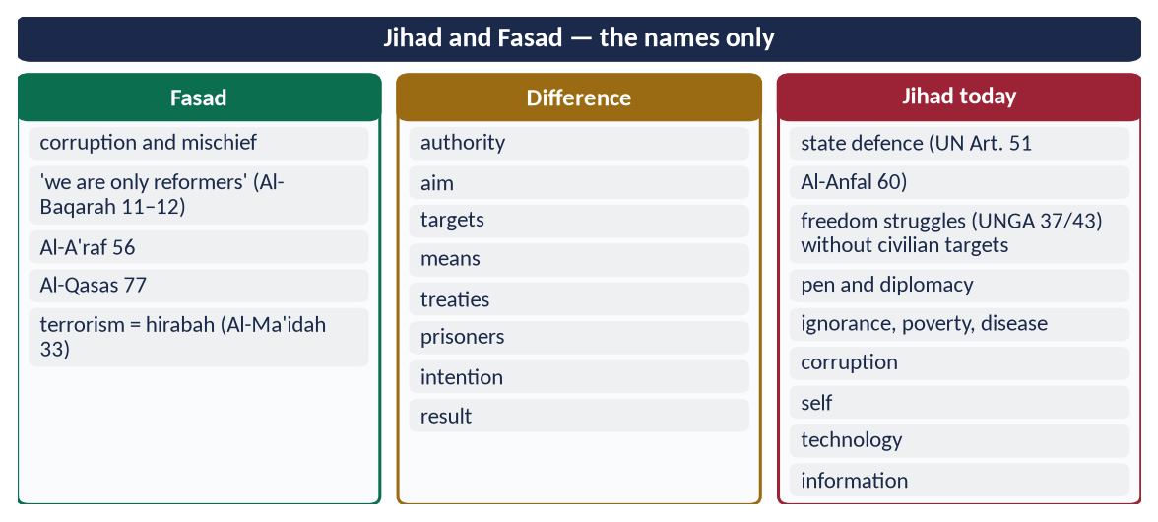
Figure 14 · At a glance — jihad and Fasad — the names only. The detail is in the sections above.

Chapter 8 · Paigham-e-Pakistan and the National Response

8.1 What Paigham-e-Pakistan is
Paigham-e-Pakistan (The Message of Pakistan) is a national narrative against extremism and terrorism, launched at the Aiwan-e-Sadr, Islamabad, on 16 January 2018. Its core is a fatwa (religious ruling) signed by over 1,800 scholars of all schools of thought — prepared through the Islamic Research Institute of the International Islamic University, Islamabad — and endorsed by the major madrasa boards of all schools.
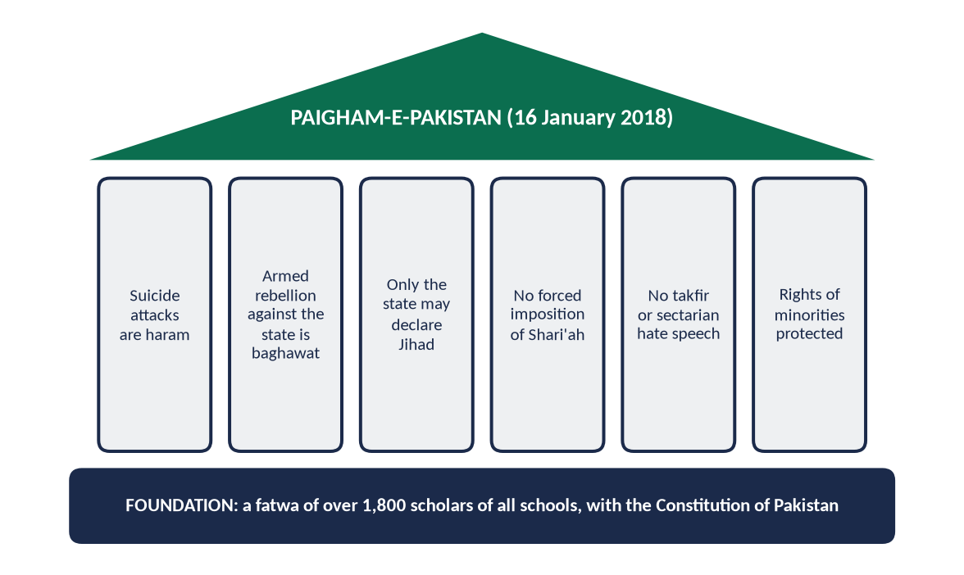
Figure 15 · Paigham-e-Pakistan: its foundation and six main pillars.

8.2 Its main points
- (a) Suicide attacks are haram — under any circumstances.
- (b) Armed rebellion against the state of Pakistan in the name of Shari'ah is baghawat (rebellion), forbidden in Islam.
- (c) Only the state may declare jihad; no individual or group may do so.
- (d) Shari'ah cannot be imposed by force; the way is peaceful and constitutional — the Constitution of Pakistan is Islamic in its foundations (Objectives Resolution, Articles 2A and 227).
- (e) No takfir by individuals; no declaring Muslims or the state disbelievers.
- (f) No sectarian hate speech; no insult to revered personalities of any school.
- (g) Rights of minorities — their life, property and places of worship are protected.
- (h) Madrasas, mosques and pulpits are not to be used for spreading hatred or violence.
✦ QURAN
﴿… مَن قَتَلَ نَفۡسَۢا بِغَيۡرِ نَفۡسٍ أَوۡ فَسَادٖ فِي ٱلۡأَرۡضِ فَكَأَنَّمَا قَتَلَ ٱلنَّاسَ جَمِيعٗا وَمَنۡ أَحۡيَاهَا فَكَأَنَّمَآ أَحۡيَا ٱلنَّاسَ جَمِيعٗاۚ …﴾
“Whoever kills a soul — unless for a soul or for corruption in the land — it is as if he had slain mankind entirely; and whoever saves one, it is as if he had saved mankind entirely.” (Al-Ma'idah, Quran)
➜ Killing one innocent soul is like killing all mankind — the verse at the heart of the fatwa.

✦ HADITH
مَنْ حَمَلَ عَلَيْنَا السِّلَاحَ فَلَيْسَ مِنَّا
“Whoever takes up arms against us is not of us.” (Al-Bukhari and Muslim)

8.3 Why it matters
- Consensus across schools — the first time scholars of all Pakistani schools signed one text against terrorism, removing the claim that terrorists speak for any sect.
- Religious authority — terrorists claim religion; Paigham-e-Pakistan answers them with religion.
- Constitutional basis — ties Islamic teaching to the Constitution and the state.
- A code of conduct — for the media, the pulpit and madrasas.
- International value — shows the world a Muslim society refuting terrorism from within.

8.4 A critical evaluation
Strengths | Weaknesses and gaps
Consensus of 1,800+ scholars of all schools | Low public awareness; few people know its content
Strong religious and constitutional basis | Weak implementation against hate speech
A clear line: only the state may declare jihad | Limited reach into online spaces where youth are radicalised
Addresses suicide attacks and takfir directly | Not fully integrated into school and madrasa curricula
A model for other Muslim countries | Resurgence of terrorism after 2021 shows narrative alone is not enough

Verdict: Paigham-e-Pakistan is the right narrative; it needs implementation — in curricula, sermons, media and law enforcement — and must be joined to justice, development and effective security.

8.5 The wider national response — an overview
- National Action Plan (2014) — 20 points (Chapter 4).
- Military operations — Rah-e-Rast (2009), Zarb-e-Azb (2014), Radd-ul-Fasaad (2017).
- NACTA (2013) and provincial counter-terrorism departments.
- National Internal Security Policy (2014–2018) and the National Security Policy (2022).
- FATA merger (2018); border fencing; FATF compliance (grey list exit, 2022).
- Madrasa registration and curriculum reform.
- De-radicalisation — Sabaoon (Swat) and similar centres.
- Paigham-e-Pakistan — the counter-narrative.

8.6 Online radicalisation — the new front
Extremist groups recruit through videos, encrypted chats and social media — reaching young people directly, bypassing family and mosque.
Responses:
- Law: the Prevention of Electronic Crimes Act (2016); action against terrorist content (NAP point 14).
- Counter-content: scholars and influencers producing short, attractive content on wasatiyyah.
- Digital literacy: teaching the young to verify (Al-Hujurat 6) and to recognise manipulation.
- Family vigilance: parents aware of their children's online life.

8.7 The role of youth and education
Pakistan's population is young — about two-thirds under 30. Youth are both the target of extremists and the best defence against them.
- Education — critical thinking; the Seerah of mercy; civic sense.
- Opportunity — skills, jobs and sports.
- Participation — debating societies, volunteering, interfaith and inter-sect youth forums.
✦ HADITH
سَبْعَةٌ يُظِلُّهُمُ اللَّهُ فِي ظِلِّهِ يَوْمَ لَا ظِلَّ إِلَّا ظِلُّهُ ... وَشَابٌّ نَشَأَ فِي عِبَادَةِ اللَّهِ
“Seven whom Allah will shade in His shade on the Day when there is no shade but His … and a young man who grew up in the worship of Allah.” (Al-Bukhari and Muslim)
➜ Righteous youth are honoured by Allah.

8.8 The role of the ulema and the media
- Ulema: a unified message from the pulpit; teaching the adab of disagreement; refusing to legitimise violence; engaging the young.
- Media: no glorification of terrorists (NAP point 11); responsible reporting of attacks; programmes that promote tolerance and national unity.

8.9 Counter-narratives across the Muslim world
- The Amman Message (2004–2005) — against takfir; recognition of the schools of law.
- The Letter to Baghdadi (2014) — a scholarly refutation of ISIS.
- The Marrakesh Declaration (2016) — the rights of religious minorities.
- The Charter of Makkah (May 2019) — issued by over 1,200 scholars under the Muslim World League, rejecting extremism and affirming human dignity and co-existence.
- Paigham-e-Pakistan (2018) — Pakistan's national consensus.
Together they show that the scholarly mainstream of the Ummah stands against extremism.

8.10 How to measure success
- Security: fewer attacks and deaths; fewer areas outside the state's writ.
- Justice: conviction rates in terrorism cases; speed of trials; protection of witnesses and judges.
- Narrative: Paigham-e-Pakistan taught in schools, madrasas and universities; sermons audited for hate speech.
- Finance: continued compliance with FATF standards; no re-emergence of banned groups under new names.
- Youth: employment, skills and participation of young people in the most affected districts.
- Harmony: fewer sectarian incidents; inter-sect and interfaith platforms active at district level.
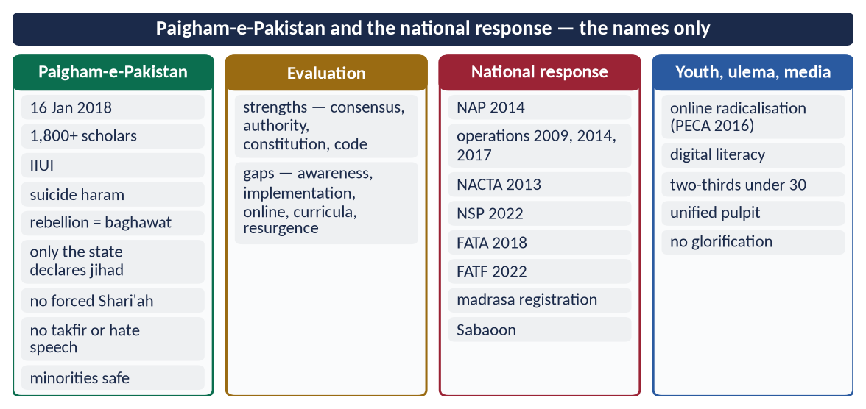
Figure 16 · At a glance — paigham-e-Pakistan and the national response — the names only. The detail is in the sections above.

Chapter 9 · Extremism and the Contemporary Challenges of the Muslim Ummah
The frame of 2019: 'Is extremism a challenge to Islam? Discuss in the context of contemporary challenges faced by Muslim Ummah.'

9.1 Extremism among the Ummah's challenges
The Ummah faces many challenges — disunity, poor governance, poverty, ignorance, occupation, Islamophobia, cultural invasion (Topic 6). Extremism is special: it is both a challenge in itself and a multiplier of all the others.
Challenge | How extremism worsens it
Disunity | Takfir and sectarian war split the Ummah further
Foreign intervention | Terror gives outside powers a pretext to invade or bomb (Afghanistan 2001, Iraq 2003)
Islamophobia | Every attack feeds anti-Muslim hatred (Topic 6, the cycle of extremisms)
Economic backwardness | Investors and tourists stay away; budgets go to security instead of schools
Education and science | Schools destroyed; girls kept out; free thinking feared
Palestine and Kashmir | Terrorism damages the moral case of legitimate causes
Refugees | Wars fuelled by extremist groups created millions of refugees (Syria, Iraq, Afghanistan)
Image of Islam | A religion of mercy is portrayed as a religion of terror

9.2 Why extremism is a challenge to Islam itself
- (a) It distorts the message: 'a mercy to the worlds' (Al-Anbiya 107) is presented as violence.
- (b) It attacks Islam's own objectives: the Maqasid protect life, faith, intellect, lineage and property; extremism destroys all five.
- (c) It hijacks religious authority: unqualified men issue fatwas of death.
- (d) It drives young Muslims away from religion: disgust with violence in God's name produces doubt and atheism.
- (e) It kills Muslims most: most victims of terrorism worldwide are Muslims.
✦ HADITH
لَا تَرْجِعُوا بَعْدِي كُفَّارًا يَضْرِبُ بَعْضُكُمْ رِقَابَ بَعْضٍ
“Do not become disbelievers after me, striking one another's necks.” (Al-Bukhari and Muslim)

9.3 The Ummah's collective response
- OIC Convention on Combating International Terrorism (1999) — a common legal framework.
- The Islamic Military Counter-Terrorism Coalition (2015) — military and ideological cooperation.
- Scholarly consensus — Amman Message (2004–05), Letter to Baghdadi (2014), Charter of Makkah (2019), Paigham-e-Pakistan (2018).
- What is still needed: an end to proxy wars between Muslim states; justice for Palestine and Kashmir through law; education and jobs for the young; a joint Muslim media voice.
✦ QURAN
﴿وَٱعۡتَصِمُواْ بِحَبۡلِ ٱللَّهِ جَمِيعٗا وَلَا تَفَرَّقُواْۚ وَٱذۡكُرُواْ نِعۡمَتَ ٱللَّهِ عَلَيۡكُمۡ إِذۡ كُنتُمۡ أَعۡدَآءٗ فَأَلَّفَ بَيۡنَ قُلُوبِكُمۡ فَأَصۡبَحۡتُم بِنِعۡمَتِهِۦٓ إِخۡوَٰنٗا …﴾
“And hold firmly to the rope of Allah all together and do not become divided. Remember Allah's favour upon you: you were enemies, and He brought your hearts together, and by His favour you became brothers.” (Aal-e-Imran, Quran)
➜ 'Hold fast to the rope of Allah all together and do not be divided.'

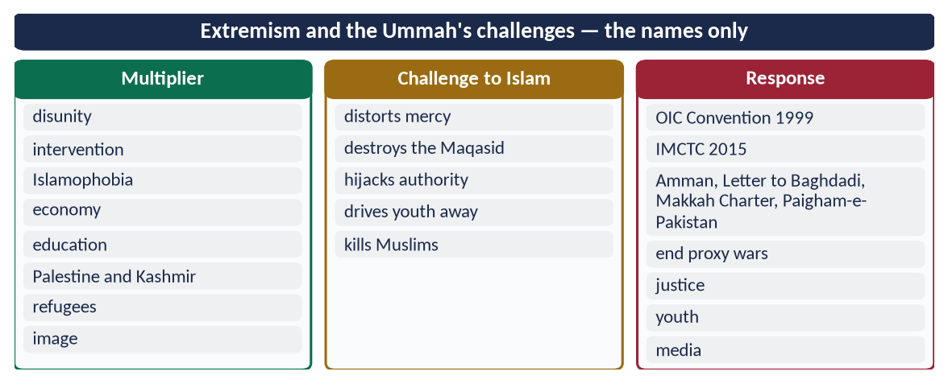
Figure 17 · At a glance — extremism and the Ummah's challenges — the names only. The detail is in the sections above.

Part Two — Contemporary Challenges, Narratives and Hot Debates

9.1 The resurgence of terrorism after 2021
After the Taliban's return to Kabul (August 2021), attacks by the TTP and separatist groups rose sharply, especially in Khyber Pakhtunkhwa and Balochistan; independent monitors counted 2024 among the deadliest years in a decade. The debate: talks or operations? The balanced view — the state negotiates only from strength, never with those who reject the Constitution, while addressing the grievances that feed recruitment (governance, jobs, justice).

9.2 Mob violence in the name of religion
Lynchings over allegations of blasphemy — such as the killing of the Sri Lankan factory manager Priyantha Kumara in Sialkot (December 2021) and the attacks on churches and homes in Jaranwala (August 2023) — brought national condemnation from scholars of all schools. The Islamic position is clear: punishment belongs to the court, after evidence; a mob that kills on suspicion commits murder and fasad.
✦ QURAN
﴿يَـٰٓأَيُّهَا ٱلَّذِينَ ءَامَنُوٓاْ إِن جَآءَكُمۡ فَاسِقُۢ بِنَبَإٖ فَتَبَيَّنُوٓاْ أَن تُصِيبُواْ قَوۡمَۢا بِجَهَٰلَةٖ فَتُصۡبِحُواْ عَلَىٰ مَا فَعَلۡتُمۡ نَٰدِمِينَ﴾
“O you who have believed, if there comes to you a disobedient one with information, investigate, lest you harm a people out of ignorance and become, over what you have done, regretful.” (Al-Hujurat, Quran)
➜ If a sinful person brings you news, verify it, lest you harm a people in ignorance and then regret what you have done.

✦ QURAN
﴿… مَن قَتَلَ نَفۡسَۢا بِغَيۡرِ نَفۡسٍ أَوۡ فَسَادٖ فِي ٱلۡأَرۡضِ فَكَأَنَّمَا قَتَلَ ٱلنَّاسَ جَمِيعٗا وَمَنۡ أَحۡيَاهَا فَكَأَنَّمَآ أَحۡيَا ٱلنَّاسَ جَمِيعٗاۚ …﴾
“Whoever kills a soul — unless for a soul or for corruption in the land — it is as if he had slain mankind entirely; and whoever saves one, it is as if he had saved mankind entirely.” (Al-Ma'idah, Quran)
➜ Killing one innocent soul is like killing all mankind.

9.3 Takfir and hate on social media
Sectarian and political hate spreads faster online than any pulpit could spread it. Solutions: enforcement of PECA 2016 and hate-speech laws; platform cooperation; counter-content by scholars; digital literacy; the Prophetic rule — 'it is enough of a lie to repeat everything one hears' (Muslim).

9.4 Madrasa reform — the debate
About 30,000 or more madrasas educate millions of children, mostly from poor families, with free food and lodging. The overwhelming majority are peaceful; a few were misused by militant groups. The debate is between control and cooperation. The balanced path: registration and audited funding; modern subjects alongside religious sciences; recognised certificates so that graduates have careers; and respect for the madrasas' role in preserving religious learning.

9.5 Extremism and the youth bulge
With two-thirds of the population under 30, the question is whether this is a dividend or a danger. Jobs, skills, sports and civic participation turn it into a dividend; neglect turns it into a pool for recruitment.

9.6 Talks or operations? The record of peace deals
Pakistan has tried peace deals with militants several times — Shakai (2004) in South Waziristan, and the Swat agreement and Nizam-e-Adl Regulation (2009). Each time the militants used the pause to regroup, and military operations followed. Talks with the TTP in 2021–22 also failed. Lesson: dialogue is Islamic and useful with those who accept the Constitution and lay down arms (Al-Ma'idah 34); with those who reject both, the state must enforce the law (Al-Hujurat 9: fight the group that transgresses until it returns).
✦ QURAN
﴿وَإِن طَآئِفَتَانِ مِنَ ٱلۡمُؤۡمِنِينَ ٱقۡتَتَلُواْ فَأَصۡلِحُواْ بَيۡنَهُمَاۖ …﴾
“And if two groups of the believers fight, then make peace between them.” (Al-Hujurat, Quran)
➜ If one of the two groups transgresses against the other, fight the one that transgresses until it returns to the command of Allah.

9.7 Security, CPEC and the economy
Attacks on Chinese engineers and on CPEC projects show that terrorism targets the economy as much as people. Security for development projects, investment in the regions they pass through, and local jobs are part of counter-terrorism.
DEBATE · IS POVERTY THE ROOT OF TERRORISM?
Partly: poverty and joblessness make recruitment easier. But not only: many terrorists were educated and middle-class; ideology, grievance and identity matter as much. The answer must therefore be both — development and a counter-narrative, justice and security.

Part Three — The Examiner's Record and Five Likely Questions

10.1 Every question on this topic, 2015–2026
Year | Question | Ch.
2015 Q3 | What is the difference between Jihad and Fasaad (Hostility)? Discuss the possibilities of practical application of Quranic concept of Jihad in current international scenario. | 7
2017 Q7 | Enumerate the reasons of extremism in Pakistan and suggest solutions to eradicate it in the light of Islamic teachings. | 3, 4
2018 Q4 | Point out the motives of terrorism in Pakistan. How can the society get rid of terrorism? | 3, 4
2019 Q7 | Is extremism a challenge to Islam? Discuss in the context of contemporary challenges faced by Muslim Ummah. | 1, 2
2020 Q5 | Discuss in detail the principles and terms & conditions for 'Jihad' in the light of Quran and Sunnah. | 6
2023 Q7 | What are the motives of extremism in Pakistan? How can the society get rid of extremism by following the teachings of Islam? | 3, 4
2024 Q7 | How is it possible to eliminate the religious and political extremism in Pakistan in the light of the teachings of the Holy Prophet (ﷺ)? Explain. | 4
2026 Q7 | Examine the causes of sectarianism and polarization in the Muslim World. Suggest solutions in the light of Islamic teachings. | 5

All eight are answered in T7QA. Related: 'Islamophobia is a sign of extremism' (2021) — Topic 6; the Ghazwat for peace (2024) — Topic 3.

10.2 What the record teaches
- Extremism in Pakistan five times (2017, 2018, 2019, 2023, 2024) — every paper since 2017 except 2020–22 and 2025.
- The questions always want causes + solutions, now tied to the Prophet's ﷺ teachings (2024) and to society (2018, 2023).
- Jihad twice — its principles (2020) and its difference from fasad (2015).
- Sectarianism entered in 2026, with the new word 'polarization'.

10.3 Five likely questions
1. What is Wasatiyyah (moderation)? How can it counter extremism in Pakistani society?
2. Discuss the Islamic rules of war and prove that terrorism has no place in Jihad.
3. Explain the role of the ulema, education and media in eradicating sectarianism in Pakistan.
4. Critically evaluate Paigham-e-Pakistan as a national narrative against extremism.
5. Takfir is the root of terrorism. Discuss in the light of the Quran and Sunnah.

Part Four — The One-Liner Bank

One-liners · Extremism and Wasatiyyah
1. Tatarruf comes from taraf — the edge.
2. The Prophet's ﷺ own word for extremism: ghuluw.
3. 'We have made you a middle nation' — Al-Baqarah 143.
4. 'Do not go to extremes in your religion' — An-Nisa 171; Al-Ma'idah 77.
5. 'Allah intends ease for you' — Al-Baqarah 185.
6. 'He has not placed upon you any hardship in religion' — Al-Hajj 78.
7. 'Beware of ghuluw in religion; it destroyed those before you' — Al-Nasa'i and Ibn Majah.
8. 'The extremists perished' (halaka al-mutanatti'un) — said three times, Muslim.
9. 'The religion is easy' — Al-Bukhari.
10. 'Whoever turns from my Sunnah is not of me' — to the three men who vowed extreme worship.
11. 'Are you a trouble-maker, O Mu'adh?' — on lengthening the prayer.
12. 'Your body has a right over you' — to 'Abdullah ibn 'Amr (RA).
13. The man who told the Prophet ﷺ 'Be just': Dhul-Khuwaysirah.
14. The Khawarij 'recite the Quran but it does not pass their throats'.
15. The Khawarij 'kill the people of Islam and leave the idol-worshippers'.
16. The Khawarij emerged after the arbitration at Siffin (657).
17. Their slogan: 'la hukma illa lillah' — 'a word of truth by which falsehood is intended' (Ali RA).
18. The Companion sent to debate the Khawarij: Ibn Abbas (RA).
19. Ali (RA) fought the Khawarij at Nahrawan (658).
20. 'The Muslim is one from whose tongue and hand Muslims are safe' — Al-Bukhari and Muslim.
21. 'We do not declare any of the people of the qiblah a disbeliever for a sin' — Al-'Aqidah al-Tahawiyyah.

One-liners · The rise of extremism
22. The Qaramitah carried off the Black Stone in 930.
23. The Soviet invasion of Afghanistan: December 1979.
24. Al-Qaeda was formed in 1988.
25. ISIS declared its 'caliphate' in 2014; it was defeated territorially by 2019.
26. The 'Letter to Baghdadi' refuting ISIS (2014) was signed by over 120 scholars.
27. Boko Haram (Nigeria) was formed in 2002; the Chibok kidnapping was in 2014.
28. The Tehrik-e-Taliban Pakistan (TTP) was formed in December 2007.
29. 'He strives to cause corruption in the land and destroy crops and life' — Al-Baqarah 205.
30. Those with deviation 'follow what is ambiguous, seeking fitnah' — Aal-e-Imran 7.
31. ISIS lost Mosul in 2017 and its last territory in 2019.
32. Afghan refugee repatriation drive from Pakistan began in 2023.

One-liners · Extremism in Pakistan
33. Afghan refugees after 1979: about 3 million.
34. Pakistanis killed in terrorism, 2001–2018: over 80,000.
35. Economic losses from terrorism, 2001–2018: over $126 billion.
36. The Lal Masjid operation: July 2007.
37. Benazir Bhutto was assassinated on 27 December 2007.
38. The Swat operation of 2009: Rah-e-Rast.
39. Operation Zarb-e-Azb began in June 2014 (North Waziristan).
40. The Army Public School attack, Peshawar: 16 December 2014 — about 147 killed.
41. The National Action Plan: 24 December 2014, 20 points.
42. Military courts were created by the 21st Amendment (2015).
43. Operation Radd-ul-Fasaad: February 2017.
44. FATA merged with Khyber Pakhtunkhwa by the 25th Amendment (2018).
45. Pakistan was on the FATF grey list from 2018 to October 2022.
46. The Peshawar Police Lines mosque bombing: 30 January 2023, about 100 killed.
47. The Jaffar Express hijacking: March 2025.
48. Global Terrorism Index 2025: Pakistan ranked second.
49. Pakistan's Anti-Terrorism Act: 1997.
50. The Indian officer arrested in Balochistan in 2016: Kulbhushan Jadhav.
51. The Sri Lankan cricket team was attacked in Lahore in March 2009.
52. The Karachi operation began in 2013.

One-liners · Eliminating extremism
53. Whoever kills a believer intentionally — his recompense is Hell — An-Nisa 93.
54. 'The believer remains in scope of his religion until he sheds forbidden blood' — Al-Bukhari.
55. 'Do not kill yourselves' — An-Nisa 29.
56. The suicide holds his weapon, stabbing himself in the Fire for ever — Muslim.
57. 'Do not say to one who offers you peace, "You are not a believer"' — An-Nisa 94.
58. 'Whoever says to his brother "O disbeliever" — it returns to one of them' — Al-Bukhari.
59. 'Did you open his heart?' — to Usamah (RA), Muslim.
60. 'Whoever prays our prayer, faces our qiblah … is a Muslim' — Al-Bukhari.
61. 'Whoever takes up arms against us is not of us' — Al-Bukhari and Muslim.
62. 'Whoever leaves obedience and the community dies a death of Jahiliyyah' — Muslim.
63. 'Changing wrong with the hand' belongs to those with lawful authority.
64. The Prophet ﷺ refused to kill Abdullah ibn Ubayy: 'people will say Muhammad kills his companions'.
65. 'No harm and no returning of harm' (la darar wa la dirar) — Ibn Majah.
66. NACTA became statutory in 2013.
67. Pakistan's National Security Policy: 2022.
68. The de-radicalisation centre in Swat: Sabaoon (2009).
69. Saudi Arabia's rehabilitation programme for militants: Munasaha.
70. Morocco trains women preachers called murshidat.

One-liners · Sectarianism
71. 'Hold fast to the rope of Allah and do not be divided' — Aal-e-Imran 103.
72. Those who divided their religion — 'you have nothing to do with them' — Al-An'am 159.
73. 'Establish the religion and do not be divided in it' — Ash-Shura 13.
74. 'Do not become disbelievers after me, striking one another's necks' — Farewell Pilgrimage.
75. 'Abusing a Muslim is sin; fighting him is kufr' — Al-Bukhari and Muslim.
76. At Banu Qurayzah, the Prophet ﷺ blamed neither group for their different readings.
77. The Imam who refused to let the Caliph impose his Muwatta: Imam Malik.
78. Al-Ghazali's work on caution in takfir: Faysal al-Tafriqah.
79. The Amman Message recognised eight schools of Islamic law.
80. The Milli Yakjehti Council was formed in 1995.
81. Pakistan's law against promoting enmity between groups: PPC 153-A.
82. Punjab Sound Systems (Regulation) Act: 2015.
83. The Saudi–Iran rapprochement was brokered in Beijing, March 2023.
84. The Kurram convoy attack: November 2024.
85. 'No private organisation capable of functioning as a military organisation' — Article 256.

One-liners · Jihad
86. Jihad comes from juhd (effort) and jahd (hardship).
87. 'Whoever fights so that the word of Allah is supreme is in the way of Allah'.
88. 'The true mujahid strives against his own self' — Al-Tirmidhi.
89. Jihad with the Quran: 'strive against them with it a great striving' — Al-Furqan 52 (Makkan).
90. 'The best jihad is a word of justice before a tyrant ruler' — Abu Dawud.
91. To a man with living parents: 'Then strive in serving them' — Al-Bukhari.
92. For women, 'the best jihad is an accepted Hajj' — Al-Bukhari.
93. The first permission to fight: Al-Hajj 39.
94. 'Fight those who fight you, but do not transgress' — Al-Baqarah 190.
95. 'Fighting is prescribed for you, though it is hateful to you' — Al-Baqarah 216.
96. 'The ruler is a shield; one fights behind him' — Al-Bukhari and Muslim.
97. Kitab al-Siyar al-Kabir: Imam Muhammad al-Shaybani (d. 805), explained by Al-Sarakhsi.
98. Prisoners are to be freed as a favour or for ransom — Muhammad 4.
99. In Hanafi fiqh, jihad is normally fard kifayah; it becomes fard 'ayn on general mobilisation.
100. The father of Islamic international law: Imam Muhammad al-Shaybani.
101. Those killed in Allah's way 'are alive with their Lord' — Aal-e-Imran 169.

One-liners · Jihad and Fasad; Paigham-e-Pakistan
102. 'We are only reformers' — the claim of the corrupters, Al-Baqarah 11–12.
103. 'Do not cause corruption after it has been set right' — Al-A'raf 56.
104. Waging war on society is hirabah — Al-Ma'idah 33.
105. The UN Charter's article on self-defence: Article 51.
106. UNGA Resolution 37/43 (1982) affirmed the right of peoples under occupation to self-determination.
107. Paigham-e-Pakistan was launched on 16 January 2018.
108. Paigham-e-Pakistan's fatwa was signed by over 1,800 scholars.
109. It was prepared through the International Islamic University, Islamabad.
110. Paigham-e-Pakistan: armed rebellion against the state is baghawat.
111. Pakistan's electronic-crimes law: PECA 2016.
112. The Sialkot lynching: December 2021; the Jaranwala attacks: August 2023.
113. The Charter of Makkah (May 2019) was issued by over 1,200 scholars.
114. The OIC Convention on Combating International Terrorism: 1999.
115. 'The verse of the sword' (At-Tawbah 5) concerns polytheists who broke their treaties (At-Tawbah 13).
ONE-LINER COUNT
This topic carries 115 one-liners, numbered 1–115. Revise them in blocks of twenty; tick the ones you can answer without looking.

Part Five — Revision Notes · Topic 7
Read these on the night before the paper. Every chapter is broken into its sections; each gives the chain of ideas, the evidence to quote, and the names, dates and numbers. The last line of each chapter tells you which question it serves.

R7.0 The whole topic in one picture
- The principle: Islam = the middle path (Al-Baqarah 143) → extremism = ghuluw → 'it destroyed those before you'.
- The first extremists: the Khawarij — takfir + violence against Muslims — refuted by Ali (RA) with dialogue first, force only against violence.
- Pakistan: Afghan-war legacy → post-9/11 → TTP (2007) → APS (2014) → NAP → decline → resurgence after 2021.
- The cure: the Prophet's ﷺ ease, mercy, sanctity of life, no takfir, no armed groups + NAP + society + Paigham-e-Pakistan.
- Jihad ≠ terrorism: jihad = state, just cause, limits, peace; terrorism = fasad and hirabah.

R7.1 Chapter 1 · Extremism and Wasatiyyah (2019)

1.1 Meaning
- tatarruf (the edge) · ghuluw (beyond the limit) → going beyond Allah's limits in belief, word, action → any rigid, intolerant, violent position.

1.2 The Islamic position (draw the middle path)
- Quran: middle nation (Al-Baqarah 143) · no ghuluw (An-Nisa 171; Al-Ma'idah 77) · ease (Al-Baqarah 185) · no hardship (Al-Hajj 78).
- Sunnah: 'beware of ghuluw' (Al-Nasa'i) · 'the extremists perished' ×3 (Muslim) · 'the religion is easy' (Al-Bukhari) · 'make easy, not hard' (Al-Bukhari and Muslim).
- Corrections: three men → 'whoever turns from my Sunnah' · Mu'adh → 'a trouble-maker?' · Ibn 'Amr → 'your body has a right'.

1.3 The Khawarij
- Prophecy: Dhul-Khuwaysirah → 'beyond their throats' → 'kill the people of Islam, leave idol-worshippers'.
- History: Siffin (657) → 'la hukma illa lillah' → Ali: 'a word of truth, falsehood intended' → Ibn Abbas debates (thousands return) → Nahrawan (658) → Ali: 'they fled from disbelief'.
- Features: takfir · literalism · violence against Muslims · contempt for scholars · self-righteousness · rebellion.

1.4–1.5 Kinds and signs
- Kinds: religious · sectarian · political · ethnic · secular · economic.
- Signs: one opinion only · making hard · harshness · suspicion · takfir · justifying violence.

1.6 Is extremism a challenge to Islam?
- A betrayal, not an expression → distorts Islam's image · kills Muslims most · divides the Ummah · destroys states · blocks progress (Swat schools) · gives enemies excuses → Al-Ma'idah 32 · 'safe from his tongue and hand'.
- Balances (1.7): world–Hereafter · body–soul · individual–society · justice–mercy · firmness–gentleness · text–reason · tradition–renewal.
- Creed against takfir (1.8): Tahawiyyah — 'no takfir of the people of the qiblah for a sin' · Abu Hanifah (Fiqh al-Akbar) — the sinner remains a believer · Iqbal: the middle community.
- Not a Muslim monopoly (2.9): Oslo 2011, Christchurch 2019, Hindutva mobs, Myanmar 2017 → a human disease; universal cure (Al-Ma'idah 8).
- Words to weapons (1.9): closed mind → contempt → takfir → dehumanisation → violence · blocked by Yusuf 76, Al-An'am 108, An-Nisa 94, Al-Ma'idah 32.
- Exam use: 2019 → thesis (betrayal) → Quran and Sunnah → Khawarij → how it harms the Ummah (use Chapter 2) → solutions.

R7.2 Chapter 2 · Rise of extremism in the Muslim world
- Early: Khawarij 657 · Qaramitah 930 (Black Stone) · Assassins.
- Turning points: 1916–24 · 1948/1967 · 1979 (Afghanistan; Iran) · Al-Qaeda 1988 · 9/11 · Iraq 2003 · Syria 2011 · ISIS 2014 → 2019 · Kabul 2021.
- Roots: ignorance · injustice/occupation · bad governance · poverty · foreign intervention · sectarian rivalry · internet.
- Groups: Al-Qaeda · ISIS · Boko Haram (2002; Chibok 2014) · Al-Shabaab · TTP (2007).
- Refutations: Amman Message · Letter to Baghdadi (2014, 120+ scholars) · Paigham-e-Pakistan.
- ISIS case: 2014 Mosul → takfir, slavery, Yazidi genocide, Palmyra → Letter to Baghdadi → Mosul lost 2017, gone 2019.
- Afghanistan: refugees (3 m+) → sanctuaries → TTP after 2021 → dialogue, fencing, repatriation (2023), operations.
- Push and pull: push (humiliation, poverty, injustice, ignorance, isolation) vs pull (belonging, money, 'justice', Paradise slogans, online heroes).
- Proof it is not Islam: Muslim victims · forbidden methods · no scholarly authority · ends in ruin → Al-Baqarah 205.

R7.3 Chapter 3 · Reasons and motives in Pakistan (2017, 2018, 2023)

3.1 Extremism vs terrorism
- Extremism = mindset; terrorism = violence against civilians/state to spread fear → every terrorist begins as an extremist → ATA 1997.

3.2 Phases (draw the timeline)
- 1979: Soviet invasion → 3 m refugees → Kalashnikov culture → 1980s sectarian outfits.
- 2001: 9/11 → militants in tribal areas → drones (from 2004).
- 2007: Lal Masjid (July) → TTP (Dec) → Benazir (27 Dec) → Swat → Rah-e-Rast 2009.
- 2014–18: Zarb-e-Azb (June 2014) → APS (16 Dec 2014, ~147) → NAP (24 Dec) → 21st Amendment → Radd-ul-Fasaad (Feb 2017) → Paigham-e-Pakistan, FATA merger (2018).
- 2021–: Kabul → TTP resurgence → Peshawar mosque (30 Jan 2023, ~100) → Jaffar Express (Mar 2025) → GTI 2025: 2nd.
- Cost: 80,000+ killed; $126 bn+ (2001–2018).

3.3 Roots (draw the tree)
- Religious: misreading · takfir · hate literature and loudspeakers · misused madrasas (a few) · forced Shari'ah → Aal-e-Imran 7.
- Political: weak writ (FATA, Balochistan) · slow justice (Swat 2008) · Afghan-era legacy · instability.
- Socio-economic: poverty · youth unemployment · 26 m out of school · injustice.
- External: foreign funding · proxies · Jadhav (2016) · Afghan havens · global grievances.
- Psychological and digital: revenge · humiliation · online recruitment · 'martyrdom' glorification.
- Legal: low convictions · terror financing (FATF 2018–22) · weak coordination.

3.3a–3.5 Cost and case studies
- Cost: 80,000+ lives · $126 bn+ · Sri Lankan team attacked, Lahore, March 2009 → no international cricket for a decade (return 2019) · schools destroyed · image, FATF.
- Swat 2007–09: slow courts + poverty → 'quick justice' → girls' schools closed → Rah-e-Rast → lesson: justice delayed.
- Karachi: ethnic + sectarian + political + criminal → operation from 2013.
- Balochistan: under-development, resource-sharing, disappearance complaints, foreign exploitation, CPEC attacks → dialogue + 18th Amendment + NFC + development (An-Nisa 135).

3.4 Motives of terrorists (2018)
- Ideological · revenge · separatist · sectarian · foreign-sponsored · criminal (extortion, kidnapping, drugs) · psychological.
- Exam use: 2017 → reasons by category + Islamic solutions; 2018 → define terrorism, phases, motives table, society's role; 2023 → motives + institution-by-institution remedies.

R7.4 Chapter 4 · Eliminating extremism (2024; second limb of 2017, 2018, 2023)

4.1 Prophet's ﷺ teachings — religious extremism
- Ease ('the religion is easy') · gentleness ('Allah loves gentleness'; the Bedouin) · life (Al-Ma'idah 32; An-Nisa 93; 'forbidden blood') · no suicide (An-Nisa 29; 'stabbing himself in the Fire') · no takfir (An-Nisa 94; 'returns to one of them'; 'did you open his heart?'; 'prays our prayer…') · no armed groups ('takes up arms against us'; 'leaves obedience… Jahiliyyah') · change wrong lawfully ('with the hand' = authority) · dialogue (Dhul-Khuwaysirah; Ibn Abbas).

4.2 Prophet's ﷺ teachings — political extremism
- Tolerance of opposition (Ibn Ubayy: 'people will say…') · shura (Ash-Shura 38; Aal-e-Imran 159; Umar at Hudaybiyyah) · truthful speech (Al-Hujurat 6, 11; 'repeating all one hears') · no harm (la darar wa la dirar) · justice to opponents (Al-Ma'idah 8) · the Charter as a pluralist model.

4.3 The state's plan
- NAP (24 Dec 2014) — 20 points: executions · military courts · no militias · NACTA · hate speech · finance · banned outfits · CT force · religious persecution · madrasas · no glorification · FATA · communications · internet · Punjab · Karachi · Balochistan · sectarian · Afghan refugees · criminal justice.
- Operations: Rah-e-Rast · Zarb-e-Azb · Radd-ul-Fasaad.
- Institutions: NACTA (2013) · ATA 1997 · CTDs · NSP 2022 · FATF exit (Oct 2022) · FATA merger (2018) · border fence.
- Madrasa registration (DGRE 2019; 2024 amendment) · Sabaoon · Paigham-e-Pakistan.

4.4 Society's role (2018, 2023)
- Family (time, supervision, online) · mosque and ulema (wasatiyyah sermons, code) · schools (critical thinking, Seerah of mercy) · madrasas (modern subjects, adab of disagreement) · media (counter-narrative, no glorification) · civil society (youth, interfaith) · economy (jobs) · justice (quick trials) → Aal-e-Imran 104.
- Education (4.4a): curriculum (Seerah of mercy, Charter, adab of disagreement, minorities) · critical thinking · teacher training · madrasa–school exchange.
- Mothers and women (4.4b): first teachers; murshidat model.
- Other countries (4.5): Saudi Munasaha · Indonesia's ex-militant voices · Morocco's imams and murshidat · Malaysia · Jordan's Amman Message.
- Justice and development (4.6): An-Nahl 90 · quick justice, police reform, jobs, services, provincial rights.
- Baghy (4.7): dissent tolerated · rebels invited to dialogue · fought only to end violence · wounded spared, fleeing not pursued, property not taken · repentance accepted.
- Repentance (4.8): Al-Ma'idah 34 → surrender before capture → rehabilitation (Sabaoon, Munasaha); victims' rights remain.
- Exam use: 2024 → two main headings — religious (4.1) and political (4.2) extremism — each from the Prophet's ﷺ teachings, then the national plan (4.3).

R7.5 Chapter 5 · Sectarianism and polarisation (2026)
- Meanings: ikhtilaf (permitted) vs tafarruq (forbidden) vs polarisation (hostile camps).
- Quran: Aal-e-Imran 103, 105 · Al-An'am 159 · Al-Anfal 46 · Ash-Shura 13 · Al-Hujurat 10.
- Sunnah: 'do not strike one another's necks' (Farewell) · 'fighting him is kufr' · 'one body'.
- Adab of disagreement: Banu Qurayzah (both accepted) · Abu Hanifah–Malik respect · Malik refuses to impose the Muwatta · Shafi'i at Abu Hanifah's grave · 'my opinion correct, possibly wrong' · Ghazali — a thousand disbelievers spared by mistake < one Muslim's blood.
- Causes: history (political disputes) · rulers and colonial divide-and-rule · geopolitics and proxies since 1979 · ignorance, takfir, hate literature, loudspeakers, rigid curricula · poverty, weak law · social media echo chambers · political hatred.
- Pakistan: 1980s–90s outfits → target killings → Karachi, Quetta, Jhang, GB, Kurram (Nov 2024) → Milli Yakjehti Council (1995) · codes of conduct · 153-A, 295-A, ATA 1997 · Punjab Sound Systems Act 2015 · Paigham-e-Pakistan.
- Kurram (5.10): Nov 2024 convoy attack → grand jirga → peace agreement Jan 2025 (weapons, bunkers, roads, compensation) → 'reconciling between people' higher than nafl worship.
- Solutions: unity on fundamentals · adab · no takfir — Amman Message (8 schools) · reconciliation (Al-Hujurat 9) · education · law · media · party dialogue · OIC · Saudi–Iran (Beijing, Mar 2023).
- Cost (5.5a): Iraq, Syria, Yemen → hundreds of thousands killed → Al-Anfal 46.
- Shared (5.8): one Allah, Prophet, Quran, qiblah, pillars, articles of faith, love of Ahl al-Bayt and Companions → Al-Anbiya 92.
- Political polarisation (5.9): hate between parties, social media abuse, distrust of institutions → Al-Hujurat 6, 11 · Al-Ma'idah 8 · Ash-Shura 38 · la darar → charter of political conduct.
- Exam use: 2026 → define → Quran/Sunnah → adab of the Imams → causes (history, geopolitics, religion, society, media, politics) → Pakistan → solutions.

R7.6 Chapter 6 · Jihad (2020)
- Meaning: juhd, jahd → striving → qital only a part → intention: 'that the word of Allah be supreme'.
- Kinds (draw the pyramid): nafs (Al-Tirmidhi; Al-Ankabut 69) · knowledge and word (Al-Furqan 52 — Makkan; 'word of justice') · wealth (As-Saff 11) · fighting · parents ('strive in serving them') · Hajj for women.
- Stages: Makkan patience → Al-Hajj 39 → Al-Baqarah 190 → At-Tawbah 36 (reciprocity) → Al-Anfal 61 (peace) · Al-Baqarah 216 (hateful).
- Principles and conditions (ten):
- State authority — 'the ruler is a shield' · Shaybani, Siyar (Hanafi) · Paigham-e-Pakistan.
- Just cause — defence, fitnah, the oppressed (An-Nisa 75), worship (Al-Hajj 40) — not land, wealth, conversion.
- Intention · invitation first (Buraydah) · treaties (Al-Anfal 58, 72).
- Non-combatants (Muslim; Abu Bakr's orders) · no transgression (Al-Baqarah 190) · prisoners (Muhammad 4; Al-Insan 8) · peace (Al-Anfal 61).
- Fard kifayah (Hanafi) → fard 'ayn on general mobilisation · parents' permission · capacity · preparation (Al-Anfal 60).
- Constitution (6.4a): Art. 245 (armed forces) · Art. 256 — no private military organisations · ATA 1997.
- Islam and Geneva (6.5): distinction · proportionality · prisoners · no perfidy · property/environment · envoys → Shaybani, father of Islamic international law.
- Martyrdom (6.6): Aal-e-Imran 169 → lawful struggle, pure intention, enemy's hand · plague, drowning, childbirth too · suicide bomber = suicide + murder, not a martyr.
- Makkan lesson (6.7): Sumayyah, Yasir, Bilal → 'be patient, O family of Yasir' → war only under a state.
- Exam use: 2020 → meaning → kinds → stages → the ten principles with a table.

R7.7 Chapter 7 · Jihad and Fasad (2015)
- Fasad: corruption, mischief → 'we are only reformers' (Al-Baqarah 11–12) · Al-A'raf 56 · Al-Qasas 77 → terrorism = hirabah (Al-Ma'idah 33).
- Difference (draw the table): authority · aim · targets · means · treaties · prisoners · intention · result · label.
- Jihad today: state defence (UN Art. 51; Al-Anfal 60) · freedom struggles (UNGA 37/43, 1982) without civilian targets · pen and diplomacy (Al-Furqan 52) · ignorance, poverty, disease · corruption ('word of justice') · the self · technology · information (An-Nahl 125).
- Not jihad: private groups · suicide attacks · rebellion · takfir.
- Misused verses (7.5): At-Tawbah 5 → treaty-breakers (At-Tawbah 13; protection in 6; exemption in 4) · Al-Baqarah 191 → limited by 190 · Al-Anfal 60 turhibun → deterrence · Al-Ma'idah 44 → 'kufr less than kufr' (Ibn Abbas).
- Exam use: 2015 → define both → difference table → practical application today (eight forms) → what is not jihad.

R7.8 Chapter 8 · Paigham-e-Pakistan and the national response
- Facts: 16 Jan 2018 · Aiwan-e-Sadr · 1,800+ scholars, all schools · IIUI (Islamic Research Institute).
- Points: suicide attacks haram · rebellion = baghawat · only the state declares jihad · no forced Shari'ah · no takfir, no sectarian hate · minorities safe · pulpits not for hate.
- Value: cross-sect consensus · religious authority · constitutional base · code of conduct · international model.
- Evaluation: strengths vs gaps (awareness, implementation, online reach, curricula, resurgence) → verdict: right narrative, needs implementation.
- Wider response: NAP · operations · NACTA · NISP 2014–18 · NSP 2022 · FATA · FATF · madrasas · Sabaoon.
- Online radicalisation: PECA 2016 · NAP 14 · counter-content · digital literacy (Al-Hujurat 6) · parents.
- Youth: two-thirds under 30 · education, opportunity, participation · 'a young man who grew up in worship' (Al-Bukhari and Muslim).
- Measuring success (8.10): attacks and deaths · convictions · Paigham-e-Pakistan in curricula · FATF compliance · youth jobs · sectarian incidents.
- Counter-narratives (8.9): Amman 2004–05 · Letter to Baghdadi 2014 · Marrakesh 2016 · Charter of Makkah (May 2019, 1,200+ scholars) · Paigham-e-Pakistan 2018.

R7.8a Chapter 9 · Extremism and the Ummah's challenges (2019)
- Multiplier: disunity · intervention pretext (2001, 2003) · Islamophobia · economy · education · Palestine/Kashmir case weakened · refugees · image.
- Challenge to Islam: distorts mercy (Al-Anbiya 107) · destroys the five Maqasid · hijacks authority · drives youth to doubt · kills Muslims → 'do not strike one another's necks'.
- Response: OIC Convention (1999) · IMCTC (2015) · scholarly consensus · end proxy wars · justice · youth · media → Aal-e-Imran 103.

R7.9 Part Two · Today
- Resurgence after 2021 → talks from strength, within the Constitution, plus grievances addressed.
- Mob violence → Sialkot (Dec 2021), Jaranwala (Aug 2023) → punishment belongs to courts (Al-Hujurat 6; Al-Ma'idah 32).
- Online takfir → PECA, counter-content, 'repeating all one hears'.
- Madrasa reform → 30,000+ madrasas → registration, audit, modern subjects, recognised certificates, respect.
- Youth bulge → dividend or danger.
- Peace deals: Shakai 2004 · Swat/Nizam-e-Adl 2009 · TTP talks 2021–22 → failed when militants rejected the Constitution → Al-Ma'idah 34 (repentance) + Al-Hujurat 9 (fight the transgressor).
- CPEC: attacks on engineers and projects → security + regional development + local jobs.
- Debate: poverty the root? → partly; ideology and grievance too → development + narrative + justice + security.

R7.10 The figures to draw in the paper
- Middle path (ghuluw — wasatiyyah — tafrit) — every extremism answer.
- Roots tree (five roots) — causes and motives.
- Pakistan timeline (1979 → 2025) — Pakistan questions.
- Jihad pyramid and stages — Jihad (2020).
- Jihad vs Fasad table — 2015.
- Paigham-e-Pakistan pillars — any national-response answer.

